

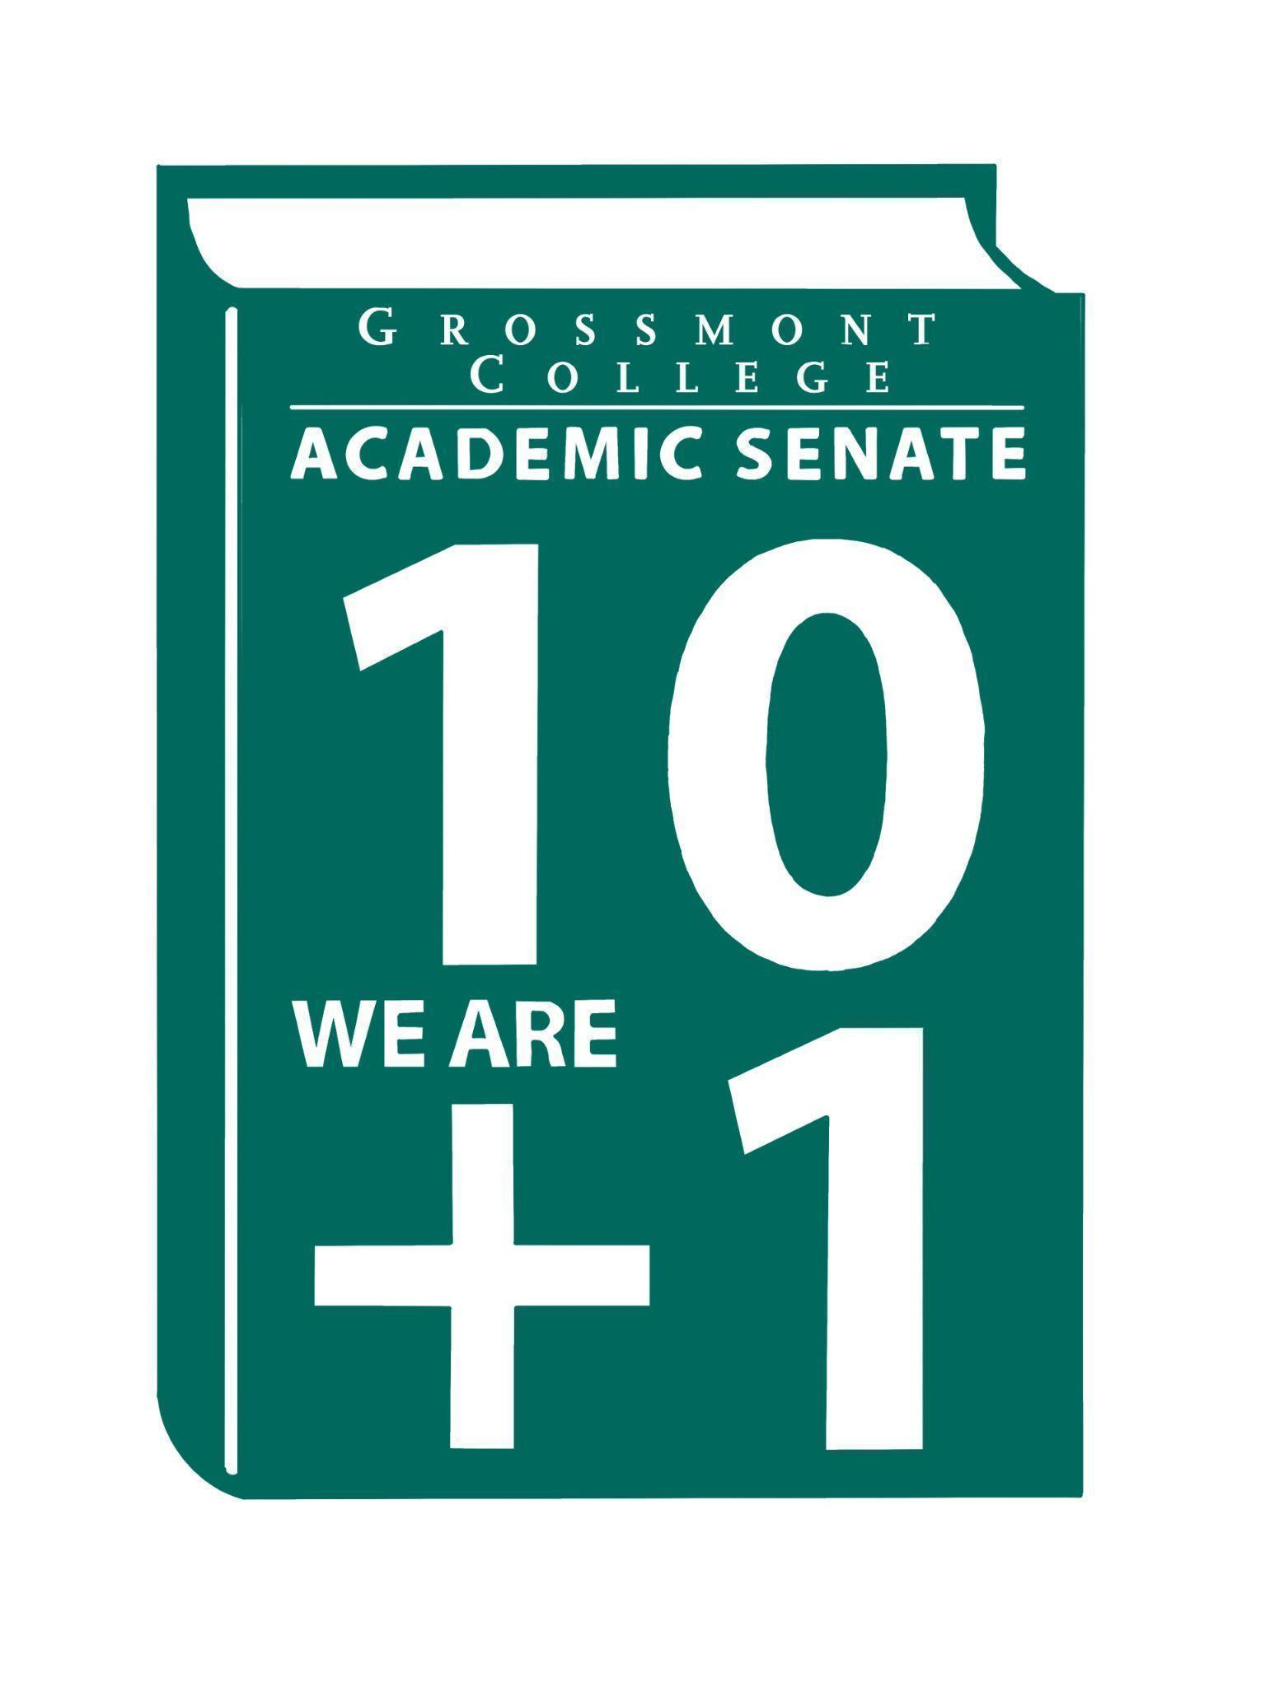

Meeting Minutes of the Academic Senate
Grossmont College
May 4, 2026
11:00 am-12:20 pm
ATTACHMENTS
1 | Call to Order 11:07 am
2 | Public Comment:  Elizabeth B. and Adelle R.- The Professional Development Committee reviewed concerns related to the union contract proposal. Among the issues discussed was the existing structure and how professional development requirements could be addressed through office hours. The committee also emphasized encouraging faculty to strengthen their skills to better support student success. Distributed a list of these concerns.
3 | Approval of minutes from April 20, 2026.  VOTE: Minutes approved with no objections  Motion: A. Ferris/J. Calo
4 | Approval of Agenda  VOTE: Agenda approved with no objections  Motion: J. Flores/C. Flores
5  5.1  5.2  5.3  5.4  5.5 | Announcements  RSI Retreat (5-1-26 Rm 26-220 @ 9:00am)  The meeting took place last Friday and included a discussion on maintaining accountability to ensure accreditation standards are met, as well as considerations for how this will be approached moving forward. A survey will be sent to collect comments, which will be synthesized and distributed. An institution report was created regarding supporting faculty.  CCCCO’s Faculty Professional Development survey (due 5-26-26)  Link from the State can be found in the agenda.  College Recognition Ceremony on May 14  Faculty will be acknowledged during the ceremony.  Entrances & Exits (annual faculty-choreographed dance concert 5/7-5/9)  Please participate.  Last Day for students to Drop Full-term Classes (with "W" 5-2-26)  Please remind students of this due date.
6  6.1  6.2  6.3  6.4  6.5  6.6 | President’s Report  Faculty/Staffing Prioritization (Please review rankings)  It was noted that approved positions may take several years to be fully implemented or filled. Information can be found in the attachments.  PSC 123 (A path forward with alignment w/ Cuyamaca)  Thanks to the Curriculum Committee for approving this path for the Physical Science department. Comments were made regarding a possible subcommittee under the Curriculum Committee.  AP/BP’s HRAC/ESSC (Please review department/division meetings)  2nd Read  - AP 7180 Employee Residency  - BP 4035 Controversial Issues/ review combined recommendations from both colleges  1st Read  AP 6450 Wireless and Cellular Telephone Use  - AP 7150 Evaluation - New  - AP/BP 7160 Professional Development - new  - AP 7348 Accommodations - new  - AP 3436 Hazing - new  - AP/BP 3510 Workplace Violence - revised  - AP 3415 Immigration Enforcement Activities  - BP 3100 Organizational Structure- revised  - AP 3300 Public Records.  MOU Process (Developed by AO/Curriculum)  Tabled to next meeting  Motion D. Aceves/J. Calo  RSI Retreat (Update)  Tabled to next meeting  Motion D. Aceves/J. Calo  Grossmont Accessibility Taskforce (GC is in the process of creating a task force to develop a formal plan and/or oversee our accessibility efforts).  Tabled to next meeting  Motion D. Aceves/J. Calo
7  7.1 | Information Items  Resolution in Support of Pan-African Virtual College-(2nd Read)
8  8.1  8.2  8.3 | Presentations  AI taskforce (15 mins)  Discussion focused on the use of AI in the classroom, with a request for faculty input on ethical considerations. Plans include gathering feedback, conducting research, and involving students in the process. A survey will be distributed to collect perspectives on how faculty envision AI being used in their classrooms, as well as how it is currently being implemented. Faculty are also encouraged to review the applicable AP and BP documents.  BDP Presentations: AOJ & Allied Health  Discussion included the potential to offer a four-year degree at Grossmont College and its value for students and the community. Emphasis was placed on how such programs could address workforce shortages, particularly in public safety fields like policing and corrections, where staffing challenges are impacting services. A four-year degree pathway at the college could serve as an investment in the future by creating strong career opportunities while remaining a more affordable option for students.  A proposal was also presented for a Bachelor of Science in Respiratory Care, highlighting the need for program expansion due to increasing healthcare complexity and the risk of program limitations or closures elsewhere. The proposal underscored a commitment to student equity and success by providing opportunities for upward mobility within the community. Strong student success outcomes, including high graduation and job placement rates, were noted as key benefits, and consideration of the proposal was encouraged.  Faculty Representatives Reports  - Senate Committees  - Participatory Governance Committees-  - Facilities/Budget/PIEC/FPSC  - EEOAC (Update-District)  - TPPG (Update-District)
9  9.1  9.2 | Action Items  GC Constitution & Bylaws (Revised)  Recommended Process to review the Senate's Constitution & Bylaws
10  10.1  10.2 | Vice-President’s Report/Unfinished Business-Tabled  Participatory Governance (open active recruitments)  Senators (Updated dept/division reps, specifically counseling)
11  11.1  11.2  11.3 | Future Agenda Items  Curriculum Committee Report-Dee Aceves  FEII Cohort-Dr. Rodriguez  Academic Senate Action Item Voting Process
12 | ASCCC Webinars, Announcements, and Resources  April 30-May 1  - The Noncredit Movement: Have you registered for the Noncredit Institute? The last day to register is April 20.  May 5, 1-2:00 pm  - Volunteering for statewide service is one of the most impactful ways faculty can contribute to the work of the Academic Senate for California Community Colleges. This session provides a clear overview of what statewide service looks like, including the types of committees and services available, who can participate, how the appointment process works, and the typical time commitment involved. We’ll discuss how faculty can identify committees that align with their interests, strengths, and leadership goals, and how statewide service can deepen your understanding of systemwide issues while strengthening your voice in academic and professional matters. Join us to learn how to get involved and what to expect when serving at the state level.  June 11-13  - 2026 Faculty Leadership Institute  - Registration Deadline: June 3, at 5:00 pm
13 | Adjournment:  VOTE: Motion to adjourn: J. Calo/D. Aceves  The meeting adjourned at 12:24.  Next meeting: May 18, 2026.

Committee Representative Communication & Feedback Form (Responses) 5/4/26

SIGN IN
5/4/2026 10:48:06 | Sébastien Cormier | Senator | Physics
5/4/2026 10:50:01 | Katie Banville | Senator | Theatre Arts
5/4/2026 10:55:26 | Denise Schulmeyer | Senator | Communication
5/4/2026 10:55:37 | Nancy saks | Guest | AHN
5/4/2026 10:57:16 | Raymond Funk | Senator | Mathematics
5/4/2026 10:57:48 | Patricia Chow | Senator | CTE/Business
5/4/2026 10:58:41 | James Holden | Senator | Biology
5/4/2026 11:00:46 | Jonathan Martin | Senator | History
5/4/2026 11:01:19 | Angela Feres | Senator | ESBS
5/4/2026 11:01:19 | Natalye Harpin | Senate Officer (Only SOC) | Ethnic studies
5/4/2026 11:02:19 | Michele perchez | Senator | Biology
5/4/2026 11:03:05 | Ryan ah | Senator | VAH
5/4/2026 11:03:20 | Carey Flores | Senator | Respiratory therapy
5/4/2026 11:03:42 | Diana Vance | Senator | Chemistry and Science
5/4/2026 11:03:48 | Michelle Crooks | Senator | English ESBS
5/4/2026 11:03:53 | Rebecca Handley | Senator | RESP
5/4/2026 11:04:19 | Jeanette Calo | Senator | MCOM
5/4/2026 11:04:21 | Nemie Capacia | Senator | Math
5/4/2026 11:04:24 | Denise Aceves | Senator | Counseling
5/4/2026 11:04:27 | June yang | Senate Officer (Only SOC) | Phil and Relg
5/4/2026 11:04:51 | Jennifer Vanden Eynden | Senator | Mathematics
5/4/2026 11:04:52 | Malia Molina | Senator | Art History
5/4/2026 11:05:03 | Scott Therkalsen | Senator | Earth sciences
5/4/2026 11:05:03 | Lara Braff | Senator | ANTH/Behavioral Sciences
5/4/2026 11:05:04 | Brodney Fitzgerald | Senator | Physics and Astronomy
5/4/2026 11:05:13 | Debbie Rose | Senator | Respiratory Therapy
5/4/2026 11:05:23 | Judd Curran | Senator | Earth Sciences
5/4/2026 11:05:25 | Elisabeth Burke | Senator | Philosophy and Religious Studies
5/4/2026 11:05:34 | Jeff Waller | Senator | Math
5/4/2026 11:05:35 | Kelly Menck | Senator | AOJ
5/4/2026 11:05:35 | natalia aylett | Senator | esl
5/4/2026 11:05:36 | Ruth Navarro | Senator | World Languages
5/4/2026 11:05:44 | Lynn Keane | Senator | BOT
5/4/2026 11:05:52 | Daniel Gough | Senator | ALC
5/4/2026 11:05:57 | Adelle Roe | Guest | English/OE
5/4/2026 11:06:12 | Felicia Kalker | Senator | Library
5/4/2026 11:06:27 | Gina Sorensen | Senator | Dance
5/4/2026 11:06:34 | Martin Larter | Senator | Chemistry
5/4/2026 11:06:46 | Joel Castellaw | Senator | Communication
5/4/2026 11:06:58 | Holly Reed | Senator | OTA
5/4/2026 11:07:19 | Wendy Cruzado | Guest | Counseling
5/4/2026 11:11:27 | Michael Perez | Senator | EOPS
5/4/2026 11:12:46 | Sarah Moore | Senator | Counseling
5/4/2026 11:14:29 | Robin Sepúlveda | Senator | CDEFS
5/4/2026 11:15:52 | Philip Bell | Senator | CSIS
5/4/2026 11:19:36 | Karen Caires | Senator | ESNH
5/4/2026 11:20:07 | Regina Garcia | Senate Officer (Only SOC) | CVT
5/4/2026 11:20:29 | Megan Konold | Senator | ESNH
5/4/2026 11:26:51 | Brian keliher | Senator | Bus adm.
5/4/2026 11:35:03 | Shawn Hicks | Guest | Math and Sciences Division
5/4/2026 11:35:29 | Gareth Davies-Morris | Senator | VAH
5/4/2026 11:35:34 | Victoria Curran | Senator | Communication

