

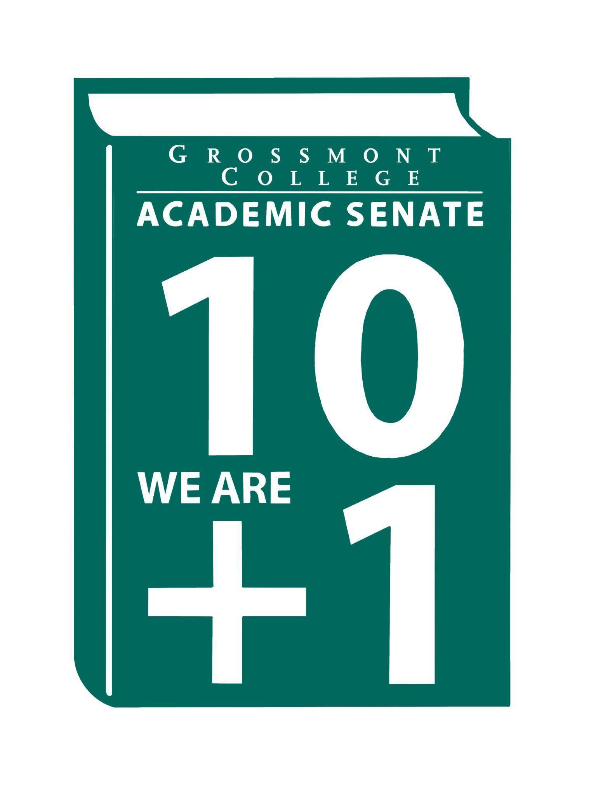

Meeting Minutes of the Academic Senate
Grossmont College
May 18, 2026
11:00 am-12:20 pm
ATTACHMENTS
1 | Call to Order 11:10am
2 | Public Comment:  Francesca M.- Celebrating the recent opening of the PRIDE Center and honoring LGBTQIA students at Lavender Graduation! Join us on June 2, 2026, from 5–7 PM on the Building 36 Terrace.
3 | Approval of minutes from May 4, 2026.  VOTE: Minutes approved with no objections  Motion: J. Waller/J. Calo
4 | Approval of Agenda  VOTE: Agenda approved with no objections  Motion: J. Calo/J. Waller
5  5.1  5.2  5.3  5.4  5.5  5.6 | Announcements  Asian American, Native Hawaiian, and Pacific Islander Heritage Month (AANHPI)  Please attend AAPI Graduation Monday June 1st from  Classified Schools Employee Week (Breakfast 5/19/26)  Held in Griffin Gate, please support.  Jewish American Heritage Month  National Military Appreciation Month  Please review the Board Agenda for updates from the District  Please pursue items.  Affinity Groups Celebration:  - Latine Graduate Celebration (5.28.26 5-6:30-Quad)  - Black and African American Graduate Celebration (5.29.26-4:00 pm @ Cuyamaca College)  Please participate in events on campus. Use QR code to register.
6  6.1  6.2  6.3  6.4  6.5 | President’s Report  Instructure (Canvas) - Ongoing Monitoring  There are emails being sent reminding everyone not to click on suspicious links.  Reassigned Time (RT) - Approval update  If reassigned time was not approved, an email notification has been sent.  AP/BP’s HRAC/ESSC (Please review department/division meetings)  2nd Read  - AP 6450 Wireless and Cellular Telephone Use  - AP 7150 Evaluation - new  - AP/BP 7160 Professional Development - new  - AP 7348 Accommodations - new  - AP 3436 Hazing - new  - AP/BP 3510 Workplace Violence - revised  - AP 3415 Immigration Enforcement Activities  - BP 3100 Organizational Structure- revised  - AP 3300 Public Records  Breaking the Cycle of Silence - Stepping Up & Speaking Up for colleagues  A conversation was held regarding challenges related to support and working conditions. Discussion centered on what it means to step up and support colleagues, particularly in situations involving bullying or demoralization. Feedback was also shared about the lack of opportunities to provide input to deans. An additional comment emphasized the importance of being an “upstander” and exploring training opportunities focused on how colleagues can better support one another. The topic will be revisited at the next Senate meeting.  Proposed changes to title 5 regulation: Distance Education  Both documents are found in attachments. Please take a look. The deadline is June 14th.
7  7.1  7.2 | Information Items  Resolution in Support of Pan African Virtual College- (2nd Read)  Please see in attachments.  MOU Process (Developed by AO/Curriculum) 1st Read (Assoc Vice Chancellor B. Gallegos)  Feedback was gathered from both Cuyamaca College and Grossmont College, and the information was synthesized to help move the process forward. It was emphasized that this is an iterative process and that current assessments indicate no breach of data privacy. The importance of holding an initial meeting with key stakeholders to review the data was also highlighted. In many cases, the MOU is already drafted prior to discussions. Comments also underscored the importance of agreements between the colleges with student success as the primary focus.
8  8.1  8.2 | Presentations  Dee Aceves-Curriculum Committee Report & Feasibility Process  Board packets and supporting documents can be found in the attachments. The Course Master List has been updated and will be posted on the Curriculum Committee website. Revisions were made to remove outdated and unnecessary information, and one board policy was removed. If you have any questions, please send an email.  Faculty Representatives Reports  - Senate Committees  - Participatory Governance Committees-  - Facilities/Budget/PIEC/FPSC  Recent campus updates include new gym bleachers and the addition of a new building. Bus shelters will be installed this summer, and the pit next to the coffee shop will be removed by next fall. HVAC issues across campus have also been addressed. Please help maintain classroom air quality by keeping all doors closed to prevent allergens from entering. Goats will be introduced over the summer to help maintain landscaping.  - EEOAC (Update-District)  - TPPG (Update-District)
9  9.1  9.2 | Action Items  GC Constitution & Bylaws (Revised)  Reviewed in multiple meetings, and the language has been updated accordingly.  Motion: J. Calo/J. Waller  Second: J. Yang  Approval: All  Abstinence: 0  Nays: 0  Motion passes unanimously  Recommended Process to review the Senate's Constitution & Bylaws  Motion: J. Calo/A. Traylor  Approval: All  Abstinence: 0  Nays: 0  Motion passes unanimously
10  10.1  10.2 | Vice-President’s Report/Unfinished Business  Participatory Governance (open active recruitments)  Senators (Updating dept/division reps, specifically counseling)
11  11.1 | Future Agenda Items  Celebration of New/Newer Faculty/Faculty & Admin Asst. embarking on a new journey/(Last Mtg of the Semester)
12 | ASCCC Webinars, Announcements, and Resources  May 19, 12-1:00 pm  - Faculty Role in the TOP to CIP Transition (Registration Link)  June 11-13  - 2026 Faculty Leadership Institute (Registration Link)  - Registration Deadline: June 3, at 5:00 pm  June 15  Mentor applications open for the 2026 Faculty Empowerment and Leadership Academy (FELA)! For further details on program requirements, please visit the Faculty Empowerment and Leadership Academy page on our website.
13 | Adjournment:  VOTE: Motion to adjourn: J. Calo/D. Aceves  The meeting adjourned at 12:20.  Next meeting: June 1, 2026.

Committee Representative Communication & Feedback Form (Responses) 5/18/26

SIGN IN
5/18/2026 10:38:03 | Natalye Harpin | Senate Officer (Only SOC) | Ethnic studies
5/18/2026 10:51:14 | Debbie Rose | Senator | Respiratory
5/18/2026 10:56:03 | Diana Vance | Senator | Chemistry and Science
5/18/2026 10:57:03 | Patricia Chow | Senator | CTE/Business
5/18/2026 10:57:03 | Sébastien Cormier | Senator | Physics
5/18/2026 10:58:54 | Gina Sorensen | Senator | Dance
5/18/2026 10:59:00 | Katie Banville | Senator | Theatre Arts
5/18/2026 10:59:22 | Ryan Gray | Senator | VAH
5/18/2026 10:59:25 | Jonathan Martin | Senator | History
5/18/2026 10:59:28 | Nemie Capacia | Senator | Math
5/18/2026 10:59:32 | Denise Schulmeyer | Senator | Communication
5/18/2026 11:00:00 | Michael Perez | Senator | EOPS
5/18/2026 11:00:05 | francheska morataya | Guest | Pride Center
5/18/2026 11:00:13 | Lara Braff | Senator | Behavioral Sciences/Anthropology
5/18/2026 11:00:24 | Michael Bacon | Senator | Psychology
5/18/2026 11:00:26 | Sarah Moore | Senator | Counseling/Transfer Center
5/18/2026 11:00:56 | Regina Garcia | Senate Officer (Only SOC) | Cardiovascular Technology
5/18/2026 11:02:19 | Martin Larter | Senator | Chemistry
5/18/2026 11:02:21 | Carey Flores | Senator | Respiratory therapy
5/18/2026 11:02:45 | Julie Schanze | Guest | Mental health
5/18/2026 11:03:15 | Robin Sepúlveda | Senator | CDEFS
5/18/2026 11:03:17 | Joel Castellaw | Senator | Communication
5/18/2026 11:03:19 | Angela feres | Senator | ESBS history
5/18/2026 11:03:22 | Scott Therkalsen | Senator | Earth sciences
5/18/2026 11:04:02 | Brodney Fitzgerald | Senator | Physics and Astronomy
5/18/2026 11:04:18 | Lynn Keane | Senator | BOT
5/18/2026 11:05:02 | Daniel Gough | Senator | ALC
5/18/2026 11:05:08 | June Yang | Senate Officer (Only SOC) | Phil and Relg
5/18/2026 11:05:27 | Holly Reed | Senator | OTA
5/18/2026 11:06:28 | Judd Curran | Senator | Earth Sciences
5/18/2026 11:06:28 | Jeff Waller | Senator | Mathematics
5/18/2026 11:07:39 | Michele Perchez | Senator | Biology
5/18/2026 11:08:07 | Victoria Curran | Senator | Communication
5/18/2026 11:08:22 | Alan Traylor | Senate Officer (Only SOC) | English
5/18/2026 11:08:58 | Selene Miles | Senator | Biology
5/18/2026 11:09:01 | Rebecca Handley | Senator | RESP
5/18/2026 11:10:08 | Diana Ramirez | Senate Officer (Only SOC) | Counseling
5/18/2026 11:10:19 | Jeanette Calo | Senator | MCOM
5/18/2026 11:11:14 | Denise Aceves | Senator | Counseling
5/18/2026 11:11:33 | Randy Abshier | Senator | ESNH
5/18/2026 11:13:22 | Natalia Aylett | Senator | ESL
5/18/2026 11:14:04 | Elisabeth Burke | Senator | Philosophy and Religious Studies
5/18/2026 11:14:08 | Jennifer Vanden Eynden | Senator | Mathematics
5/18/2026 11:15:28 | Karen Caires | Senator | ESNH
5/18/2026 11:20:19 | Gareth Davies-Morris | Senator | Visual Arts and Humanities
5/18/2026 11:20:47 | Malia Molina | Senator | Art History
5/18/2026 11:32:18 | Barbara Gallego | Guest | District-Ed Support Services
5/18/2026 11:36:48 | Megan Konold | Senator | ESNH

