

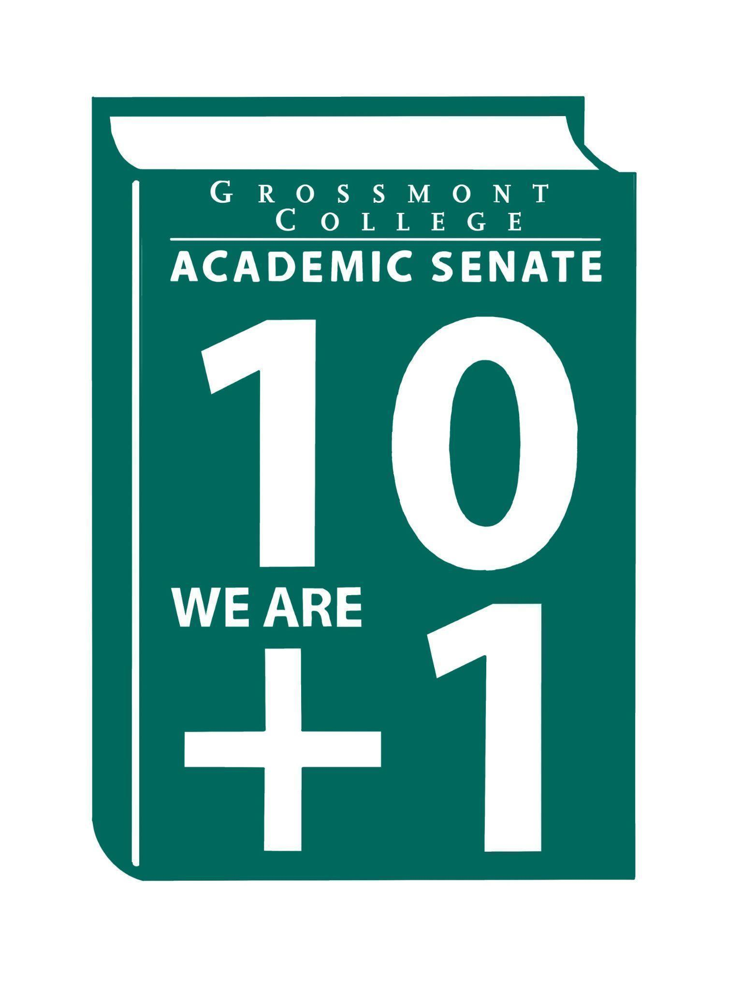

Meeting Minutes of the Academic Senate
Grossmont College
April 6, 2026
11:00 am-12:20 pm
ATTACHMENTS
1 | Call to Order 11:12 am
2 | Public Comment:  Daniel G.-Celebrate Deaf History Month this April! Join the team for ASL Role Day on April 15th—we’d love to see you there.  James F.-Personal reasons were shared for advocating the preservation of the German program at Grossmont College, including how it supports and complements other programs such as Philosophy and other humanities studies.  Brodney F.-A Q&A session for the Faculty Staffing Prioritization Committee will be held in Building 31, Room 107 this Friday, April 10th, from 1:00–4:00 PM.
3 | Approval of minutes from March 16, 2026.  VOTE: Minutes approved with no objections  Motion: J. Waller/A. Traylor
4 | Approval of Agenda  VOTE: Agenda approved with no objections  Motion: J. Calo/J. Waller
5  5.1  5.2  5.3  5.4  5.5 | Announcements  Call-out for volunteers to serve on the Participatory Governance Committees (deadline to apply 4-23-26)  Arab Heritage Month (Please see calendar of events)  Encourage students to participate and engage in campus activities.  Americans and the Holocaust traveling exhibition coming to Grossmont College Library (4-14-26 thru 5-21-26)  Please encourage students to participate in this extraordinary event. The community is excited that this exhibition is being hosted at GC.  2026 Graduation Ceremony (Distinguished Faculty Presentation was removed as a component of the graduation ceremony.  There will still be an acknowledgement, just not a speech. The goal of this is to create a bigger emphasis on students during the ceremony. The Distinguished Faculty selected will be celebrated at the last Senate meeting. Please send an email with any thoughts or recommendations to honor and celebrate our colleagues.  Griffin Grind is open for business (the old Java Market) in Building 60  Please visit and provide feedback.
6  6.1  6.2  6.3  6.4 | President’s Report  Districts Accessibility Plan  The plan was distributed after the agenda was posted, and an email with the plan will be sent out to the collective. This document provides a high-level overview of the Digital Accessibility Action Plan, please review it.  A question was raised about the distinction between the college and the district, particularly regarding services. The district provides services for both Cuyamaca College and Grossmont College, while the college leadership focuses specifically on strategic goals for Grossmont College.  Spring Plenary Resolutions (Please review -Plenary is 4/9/26)  ASCCC Spring Plenary is Thursday through Saturday. Some resolutions may impact faculty directly. Faculty were reminded to send feedback on resolutions with recommendations on voting any particular resolution.  Participatory Governance Guidelines (Roles and Responsibilities)  Email will be sent out regarding information on upcoming Senate and Participatory Governance committees. In this email communication, information will be shared regarding the roles and responsibilities of the representatives. Faculty are encouraged to share their feedback.  Human Resources Advisory Council (HRAC): AP/BPs AP 7180: Employee Residency  Please add your feedback in the comments section. Avoid editing any CCLC language as it is mandated.
7  7.1  7.2  7.3  7.4  7.5  7.6  7.7  7.8 | Information Items  Draft of District MOU Approval & Implementation Process  Please provide feedback. Dee A. noted that the AO’s are drafting a process based on their critical insights and independent research.  Recommended Process to review the Senate's Constitution & Bylaws Academic  Please check out before we move to action item at next meeting  Senate Action Item Voting Process  Recommend additional feedback.  BP 4035 Controversial Issues (Please review with department and provide feedback in the comments sections-use the green font)  AP/BP 4230 Grading and Academic Symbols (Please review with the department and provide feedback in the comments sections. GC faculty are encouraged to use the green font)  AP 4222-Pre-Collegiate Basic Skills Coursework (Please review with department and provide feedback in the comments sections-use the green font)  AP/BP- 3775 AI Policy (Please Review)  Comments were raised about how Copilot in the Microsoft Suite may extract information from emails, which raises concerns about how sensitive data is being handled. It is recommended not to enter personally identifiable information into Copilot. Additionally, some AI tools may access and analyze content uploaded to Canvas. While Canvas courses can be made public, content typically cannot be scraped unless it is publicly available or shared through student uploads.
8  8.1  8.2  8.3  8.4 | Presentations  Professional Advancement Committee (Academic Rankings)  Accreditation Findings Review (Accreditation Taskforce)  The process, key findings, focus areas, and next steps were reviewed.  Current efforts include:  Faculty will receive guidance via email. Instructors should include office hours in syllabi, provide individualized feedback in SpeedGrader, and engage regularly with students through discussions or Q&A. The Online Teaching and Learning Committee is reviewing peer responses and will offer recommendations.  Accreditation RSI Core Inquiry  PIEC: Student Survey (Malia & Tate)  A survey has been created to gauge the student experience at Grossmont College.  - One of the key components of the Student Equity Plan (first gen, students of color)  - Developed by reviewing Student Climate surveys from across the state/nation  - Worked with Student Success and Equity and with the PIEC Committees to refine drafts  - A concern about individuals being called out  - All individual references will be scrubbed  - Had 5 students do a test run to ensure it was clear and manageable  - clear/easy to understand  - Only 15 minutes to complete  - There were two answers that seemed similar-so we deleted one  General focus:  - Degree to which students feel accepted, supported, directed, engaged, safe, and respected  - Each through multiple lenses:  - Individual (general) experience  - Racial identity  - gender/sexual identity  - Socio-economic status  - Immigration status  - Each also related to:  - Student services  - Instruction  - Campus social life  Concerns were raised about the survey’s 15-minute length; however, it was noted that students did not find this to be an issue.  Student Climate Survey Draft  ACCJC Quality Continuum Rubric for Distance Education September 2024 Pilot  Faculty Representatives Reports  - Senate Committees  - Participatory Governance Committees-  - Facilities/Budget/PIEC/FPSC  - EEOAC (Update-District)  - TPPG (Update-District)
9  9.1 | Action Items  GC Constitution & Bylaws (Revised)  Tabled to the next meeting.  Motion J. Waller/J. Vanden Eynden
10  10.1  10.2 | Vice-President’s Report/Unfinished Business-Tabled  Participatory Governance (open active recruitment)  Senators (Updated dept/division reps, specifically counseling)
11  11.1  11.2  11.3 | Future Agenda Items  AI Taskforce  CPL Update  College President’s Forum-tentative
12 | ASCCC Webinars, Announcements, and Resources  - Common Course Numbering (CCN) Office Hours  Wednesday, April 1, 2-3:00 pm  Monday, April 27, 1-2:00 pm  - The Academic Freedom Resource Guide is intended to support faculty with information to ensure they know their roles, rights, and responsibilities in the use of academic freedom; it includes links to a Playlab.ai bot trained to support research on academic freedom
13 | Adjournment:  VOTE: Motion to adjourn: R. Garcia/J. Vanden Eynden  The meeting adjourned at 12:22.  Next meeting: April 20, 2026.

Committee Representative Communication & Feedback Form (Responses) 4/6/26

SIGN IN
4/6/2026 10:49:43 | Natalye Harpin | Senate Officer (Only SOC) | ETHN/ ADSOC
4/6/2026 10:54:17 | Randy Abshier | Senator | ESNH
4/6/2026 10:57:00 | Selene Miles | Senator | Biology
4/6/2026 10:57:07 | James Holden | Senator | Biology
4/6/2026 10:57:37 | Michele Perchez | Senator | Biology
4/6/2026 10:58:13 | Brian keliher | Senator | Bus adm.
4/6/2026 10:58:19 | Kathleen Banville | Senator | Theatre Arts
4/6/2026 10:58:41 | Nancy Sals | Guest | AhN
4/6/2026 10:59:03 | Evie Kensel | Guest | Child Development
4/6/2026 10:59:46 | Nemie Capacia | Senator | Math
4/6/2026 11:00:29 | Ryan Gray | Senator | Vah
4/6/2026 11:01:30 | Daniel Gough | Senator | ALC
4/6/2026 11:02:15 | Diana Vance | Senator | Chemistry and Science
4/6/2026 11:02:35 | Carey Flores | Senator | Respiratory therapy
4/6/2026 11:02:40 | Lara Braff | Senator | ANTH/Behavioral Sciences
4/6/2026 11:03:38 | denise schulmeyer | Senator | communication
4/6/2026 11:03:49 | Judd Curran | Senator | Earth Sciences
4/6/2026 11:03:53 | Lynn Keane | Senator | BOT
4/6/2026 11:04:14 | Karen Hern | Senator | Business Administration
4/6/2026 11:04:23 | Gina Sorensen | Senator | Dance
4/6/2026 11:04:37 | Jazmyn Brown | Guest | Dance
4/6/2026 11:04:50 | Natalia Aylett | Senator | ESL
4/6/2026 11:05:17 | Martin Larter | Senator | Chemistry
4/6/2026 11:05:41 | Holly Reed | Senator | OTA
4/6/2026 11:05:51 | Raymond Funk | Senator | Math
4/6/2026 11:06:30 | Jeff Waller | Senator | Mathematics
4/6/2026 11:06:39 | Julie Schanze | Guest | Mental health
4/6/2026 11:06:42 | Brodney Fitzgerald | Proxy for Senator | Physics and Astronomy | Sebastien Cormier
4/6/2026 11:06:42 | Debbie Rose | Senator | Respiratory
4/6/2026 11:06:58 | Jonathan Martin | Senator | History
4/6/2026 11:07:02 | Ricardo crespo | Senator | Political economy
4/6/2026 11:07:03 | Patricia Chow | Senator | CTE/Business
4/6/2026 11:07:13 | Tate Hurvitz | Guest | CPIE
4/6/2026 11:07:21 | Michelle Crooks | Senator | English
4/6/2026 11:07:35 | Regina Garcia | Senate Officer (Only SOC) | Cardiovascular Technology
4/6/2026 11:07:54 | Denise Aceves | Senator | Counseling
4/6/2026 11:09:45 | Karen Caires | Senator | Exercise Science, Nutrition and Health
4/6/2026 11:10:08 | Dawn Heuft | Guest | Ltr
4/6/2026 11:12:54 | Elisabeth Burke | Senator | Philosophy and Religious Studies
4/6/2026 11:12:54 | Robin Sepulveda | Senator | CDEFS
4/6/2026 11:13:18 | Philip Bell | Senator | CSIS
4/6/2026 11:15:12 | Jeanette Calo | Senator | MCOM
4/6/2026 11:15:19 | Jennifer Vanden Eynden | Senator | Mathematics

