

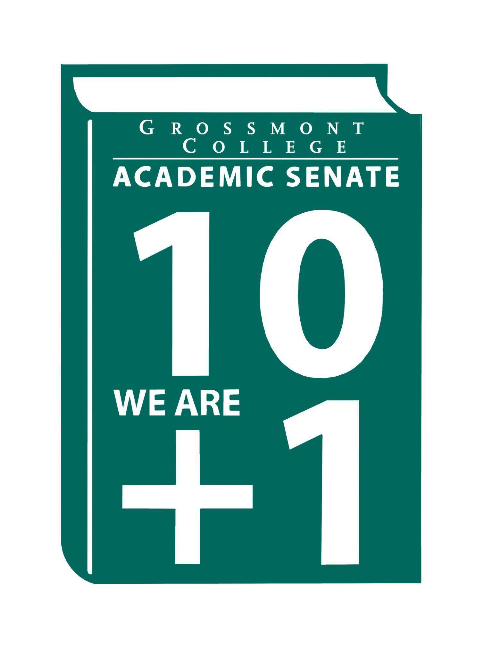

Meeting Minutes of the Academic Senate
Grossmont College
April 20, 2026
11:00 am-12:20 pm
ATTACHMENTS
1 | Call to Order 11:05 am
2 | Public Comment:  Lara B.-Spring Member Social on Tuesday, April 21st, from 1:00–3:00 pm on the Terrace, featuring Thai food and live music.  Vicky R.- The German program at Grossmont College will not continue in the fall semester, leaving students in German II without the opportunity to advance to higher-level courses. Supporters are advocating for the program’s continuation, with a petition that has gathered 150 signatures. They emphasize that studying German enriches other fields such as mathematics and philosophy.
3 | Approval of minutes from April 6, 2026.  VOTE: Minutes approved with no objections  Motion: A. Feres/L. Braff/J. Vanden Eynden
4 | Approval of Agenda  VOTE: Agenda approved with no objections  Motion: A. Ferris/C. Flores
5  5.1  5.2  5.3  5.4  5.5 | Announcements  Reminder-request for volunteers to serve on the Participatory Governance Committees (Deadline to apply 4-30-26)  *Correction: The agenda notes listed the deadline as the 23rd, but it has been corrected to the 30th.  Black Student Success Week (April 20-24; 12-1 pm-The Village )  Email sent to join the Village or join virtually.  Distinguished Faculty Nominations (Deadline to submit 4-24-26)  Student of Note Nominations (Deadline to submit 4-24-26)  Last Day for students to Drop Full-term Classes (with "W" 5-2-26)  Encourage students to seek advice from counselors.
6  6.1  6.2  6.3  6.4 | President’s Report  Spring Plenary Resolutions (Final Resolutions are available on the ASCCC website)  The math resolution was read at the Spring Plenary.  The College President is planning a forum (Please register to attend)  Participatory Governance Guidelines (Roles and Responsibilities)  Moved to the next meeting  Academic Ranking (Voting facilitated electronically)  Thank you for nominating faculty.
7  7.1  7.2  7.3 | Information Items  Resolution in Support of Pan-African Virtual College  The attached resolution, adopted from Los Rios, was presented at the Spring Plenary. Its goal is to use the virtual college platform to enable students to participate in various African colleges, and vice versa.  BP 4035-Controversial Issues  Cuyamaca’s draft will be shared. Please provide any input before it is sent forward.  BP 4010 Academic Calendar  Please review.
8  8.1  8.2  8.3 | Presentations  OTLC Committee-RSI Recommendations (15 mins)  RSI Core Inquiry: There is currently no required training, though optional training is available. A required certification may be introduced in the future. A self-check process is not yet in place, but a draft has been completed and is ready to implement. Final steps are underway; however, ongoing audit and remediation are currently not permitted under the contract.  There are gaps in training implementation, and this is being addressed as a teaching-and-learning issue. For questions or comments, please contact grossmont.canvas@gcccd.edu.  Emphasizes the importance of instructor–student interaction, with meaningful engagement required to meet RSI standards.  It was asked whether the Senate could encourage instructor-initiated instruction. Faculty can use their collective voice to ask the union to follow up on and act upon their suggestions.  Regarding peer evaluations, there has been discussion about adapting the evaluation form for online-specific courses. However, this change has not yet been successfully implemented and is still in progress.  Efforts are being made to support staff through funding for applications. A tool like “Pronto” was considered, but due to significant price increases, it will not be used. Alternative tools are currently being explored.  Credit for Prior Learning (CPL) Evan Wirig  Overview of CPL: covers various groups and how their experiences contribute to earning credit. Includes definitions of Prior Learning Assessment (PLA) and Credit for Prior Learning (CPL), as well as CPL/MAP/PLA practices in California.  Focus on military credit, including the ACE Military Guide, evaluation factors, and proposed steps for assessing prior learning based on military experience.  Faculty Representatives Reports  - Senate Committees  - Participatory Governance Committees-  - Facilities/Budget/PIEC/FPSC  - EEOAC (Update-District)  - TPPG (Update-District)
9  9.1  9.2 | Action Items  GC Constitution & Bylaws (Revised)  Recommended Process to review the Senate's Constitution & Bylaws
10  10.1  10.2 | Vice-President’s Report/Unfinished Business-Tabled  Participatory Governance (open active recruitments)  Senators (Updated dept/division reps, specifically counseling)
11  11.1  11.2  11.3 | Future Agenda Items  AI Taskforce  College Recognition Ceremony  Academic Senate Action Item Voting Process
12 | ASCCC Webinars, Announcements, and Resources  April 18, 10:00 am-3:00 pm  - Come join us in person or via Zoom to network, share, and discuss with other Rising Scholars faculty. We hope to gather Rising Scholars faculty coordinators, counselors, and instructors both inside and outside system facilities. There will be opportunities for coordinators and counselors to share and discuss issues related to coordinating programs and Rising Scholars, as well as for instructional faculty teaching Rising Scholars, both inside and outside facilities, to discuss pedagogy with other Rising Scholars faculty. The ASCCC Rising Scholars Faculty Advisory Committee will also take input from these consortia on which future resources to develop and topics for webinars and convenings, developed by Rising Scholars faculty for Rising Scholars faculty.  April 24, 1-2:00 pm  - Join the ASCCC Part-Time Faculty Committee for a special one-hour Zoom webinar celebrating the outstanding work part-time faculty are doing across California's community colleges. This event provides an opportunity for part-time faculty to share their unique contributions to student success and today's dynamic learning experiences. Come be part of this engaging session as we shine a spotlight on the dedication, innovation, and impact that part-time faculty bring to their classrooms every day.  Monday, April 27, 1-2:00 pm  - The Academic Freedom Resource Guide is intended to support faculty with information to ensure they know their roles, rights, and responsibilities in the use of academic freedom; it includes links to a Playlab.ai bot trained to support research on academic freedom  April 29, 11:00 am-12:00 pm  - Do you have questions and/or curiosity about AI and teaching strategies, class policies, student or instructor use of AI tools, or any other topic around AI and pedagogy? Join these office hours to ask your questions, bounce your ideas off attendees, or even just listen to what other faculty have to share/ask. Feel free to enjoy your snack/beverage/lunch with us while you attend.  April 30-May 1  - The Noncredit Movement: Have you registered for the Noncredit Institute? The last day to register is April 20.  May 5, 1-2:00 pm  - Volunteering for statewide service is one of the most impactful ways faculty can contribute to the work of the Academic Senate for California Community Colleges. This session provides a clear overview of what statewide service looks like, including the types of committees and services available, who can participate, how the appointment process works, and the typical time commitment involved. We’ll discuss how faculty can identify committees that align with their interests, strengths, and leadership goals, and how statewide service can deepen your understanding of systemwide issues while strengthening your voice in academic and professional matters. Join us to learn how to get involved and what to expect when serving at the state level.
13 | Adjournment:  VOTE: Motion to adjourn: D. Aceves/A. Feres  The meeting adjourned at 12:22.  Next meeting: May 4, 2026.

Committee Representative Communication & Feedback Form (Responses) 4/6/26

SIGN IN
4/20/2026 10:42:55 | Amanda Clay | Senator | Orthopedic Tech Program
4/20/2026 10:52:14 | Evan Wirig | Senator | MCOM
4/20/2026 10:52:49 | Angela Feres | Senator | History
4/20/2026 10:53:34 | Samuel Gallamore | Guest | German
4/20/2026 10:54:59 | Daniel Gough | Senator | ALC
4/20/2026 10:55:03 | Janine Morales | Guest | World language
4/20/2026 10:56:13 | Karen caires | Senator | ESNH
4/20/2026 10:57:09 | Randy Abshier | Senator | ESNH
4/20/2026 10:58:03 | Malia Molina | Senator | Art History/ALC
4/20/2026 10:58:10 | Sébastien Cormier | Senator | Physical
4/20/2026 10:58:25 | Nemie Capacia | Senator | Math
4/20/2026 10:58:31 | Patrice Braswell | Senator | A.R.C.
4/20/2026 10:58:44 | Jenny Vanden Eynden | Senator | Math
4/20/2026 10:58:51 | Vicky Ripart | Guest | World Languages/ German
4/20/2026 11:00:19 | Adelle Roe | Guest | English
4/20/2026 11:00:25 | Joel Castellaw | Senator | Communication
4/20/2026 11:00:39 | Regina Garcia | Senate Officer (Only SOC) | Cardiovascular Technology
4/20/2026 11:00:41 | Jonathan Martin | Senator | History
4/20/2026 11:00:56 | Natalye Harpin | Senate Officer (Only SOC) | Ethnic Studies
4/20/2026 11:01:04 | Carey Flores | Senator | Respiratory therapy
4/20/2026 11:01:12 | Denise Schulmeyer | Senator | Communication
4/20/2026 11:01:44 | Debbie Rose | Senator | Respiratory
4/20/2026 11:02:14 | Ryan Gray | Senator | Vah
4/20/2026 11:02:45 | Ruth navarro | Senator | World Languages
4/20/2026 11:02:51 | Julie Schanze | Guest | Mental health
4/20/2026 11:03:49 | Holly Reed | Senator | OTA
4/20/2026 11:04:30 | Judd Curran | Senator | Earth Sciences
4/20/2026 11:04:37 | Gina Sorensen | Senator | Dance
4/20/2026 11:04:54 | Brodney Fitzgerald | Senator | Physics and Astronomy
4/20/2026 11:04:58 | James Holden | Senator | Biology
4/20/2026 11:05:14 | Sarah Moore | Senator | Counseling
4/20/2026 11:05:18 | Martin Larter | Senator | Chemistry
4/20/2026 11:05:29 | Scott Therkalsen | Senator | Earth sciences
4/20/2026 11:05:30 | Wendy Cruzado | Guest | Wendy Cruzado
4/20/2026 11:05:37 | Lynn Keane | Senator | BOT
4/20/2026 11:05:49 | June yang | Senate Officer (Only SOC) | Phil and Relg
4/20/2026 11:05:51 | Selene Miles | Senator | Biology
4/20/2026 11:06:03 | Megan Konold | Senator | ESNH
4/20/2026 11:06:04 | Tate Hurvitz | Guest | CPIE
4/20/2026 11:06:16 | Lara Braff | Senator | Anthro/Behavioral Sciences
4/20/2026 11:06:17 | Alan Traylor | Senate Officer (Only SOC) | English
4/20/2026 11:06:36 | Robin Sepúlveda | Senator | CDEFS
4/20/2026 11:06:46 | Felicia Kalker | Senator | Library
4/20/2026 11:07:11 | Diana Ramirez | Senate Officer (Only SOC) | Counseling
4/20/2026 11:07:21 | Nancy Saks | Guest | AHN
4/20/2026 11:07:22 | Dawn Heuft | Guest | Ltr
4/20/2026 11:07:23 | Shawn Hicks | Guest | Math and Sciences Division
4/20/2026 11:08:02 | Jeff Waller | Senator | Mathematics
4/20/2026 11:08:13 | Michael Bacon | Senator | Psychology
4/20/2026 11:08:47 | Jeanette Calo | Senator | MCOM
4/20/2026 11:09:02 | Victoria Curran | Senator | Communication
4/20/2026 11:10:07 | Kathleen Banville | Senator | Theatre Arts
4/20/2026 11:10:58 | Elisabeth Burke | Senator | Philosophy and Religious Studies
4/20/2026 11:11:06 | Natalia Aylett | Senator | ESL
4/20/2026 11:12:03 | Rebecca Handley | Senator | RESP
4/20/2026 11:12:04 | Diana Vance | Senator | Chemistry and Science
4/20/2026 11:13:43 | Denise Aceves | Senator | Counseling
4/20/2026 11:19:45 | Patricia Ann Chow | Senator | CTE /Business
4/20/2026 11:28:23 | Gareth Davies-Morris | Senator | Visual Arts and Humanities
4/20/2026 11:28:29 | Agustin Albarran | Guest | ESBS Division
4/20/2026 11:35:45 | Philip Bell | Senator | CSIS

