

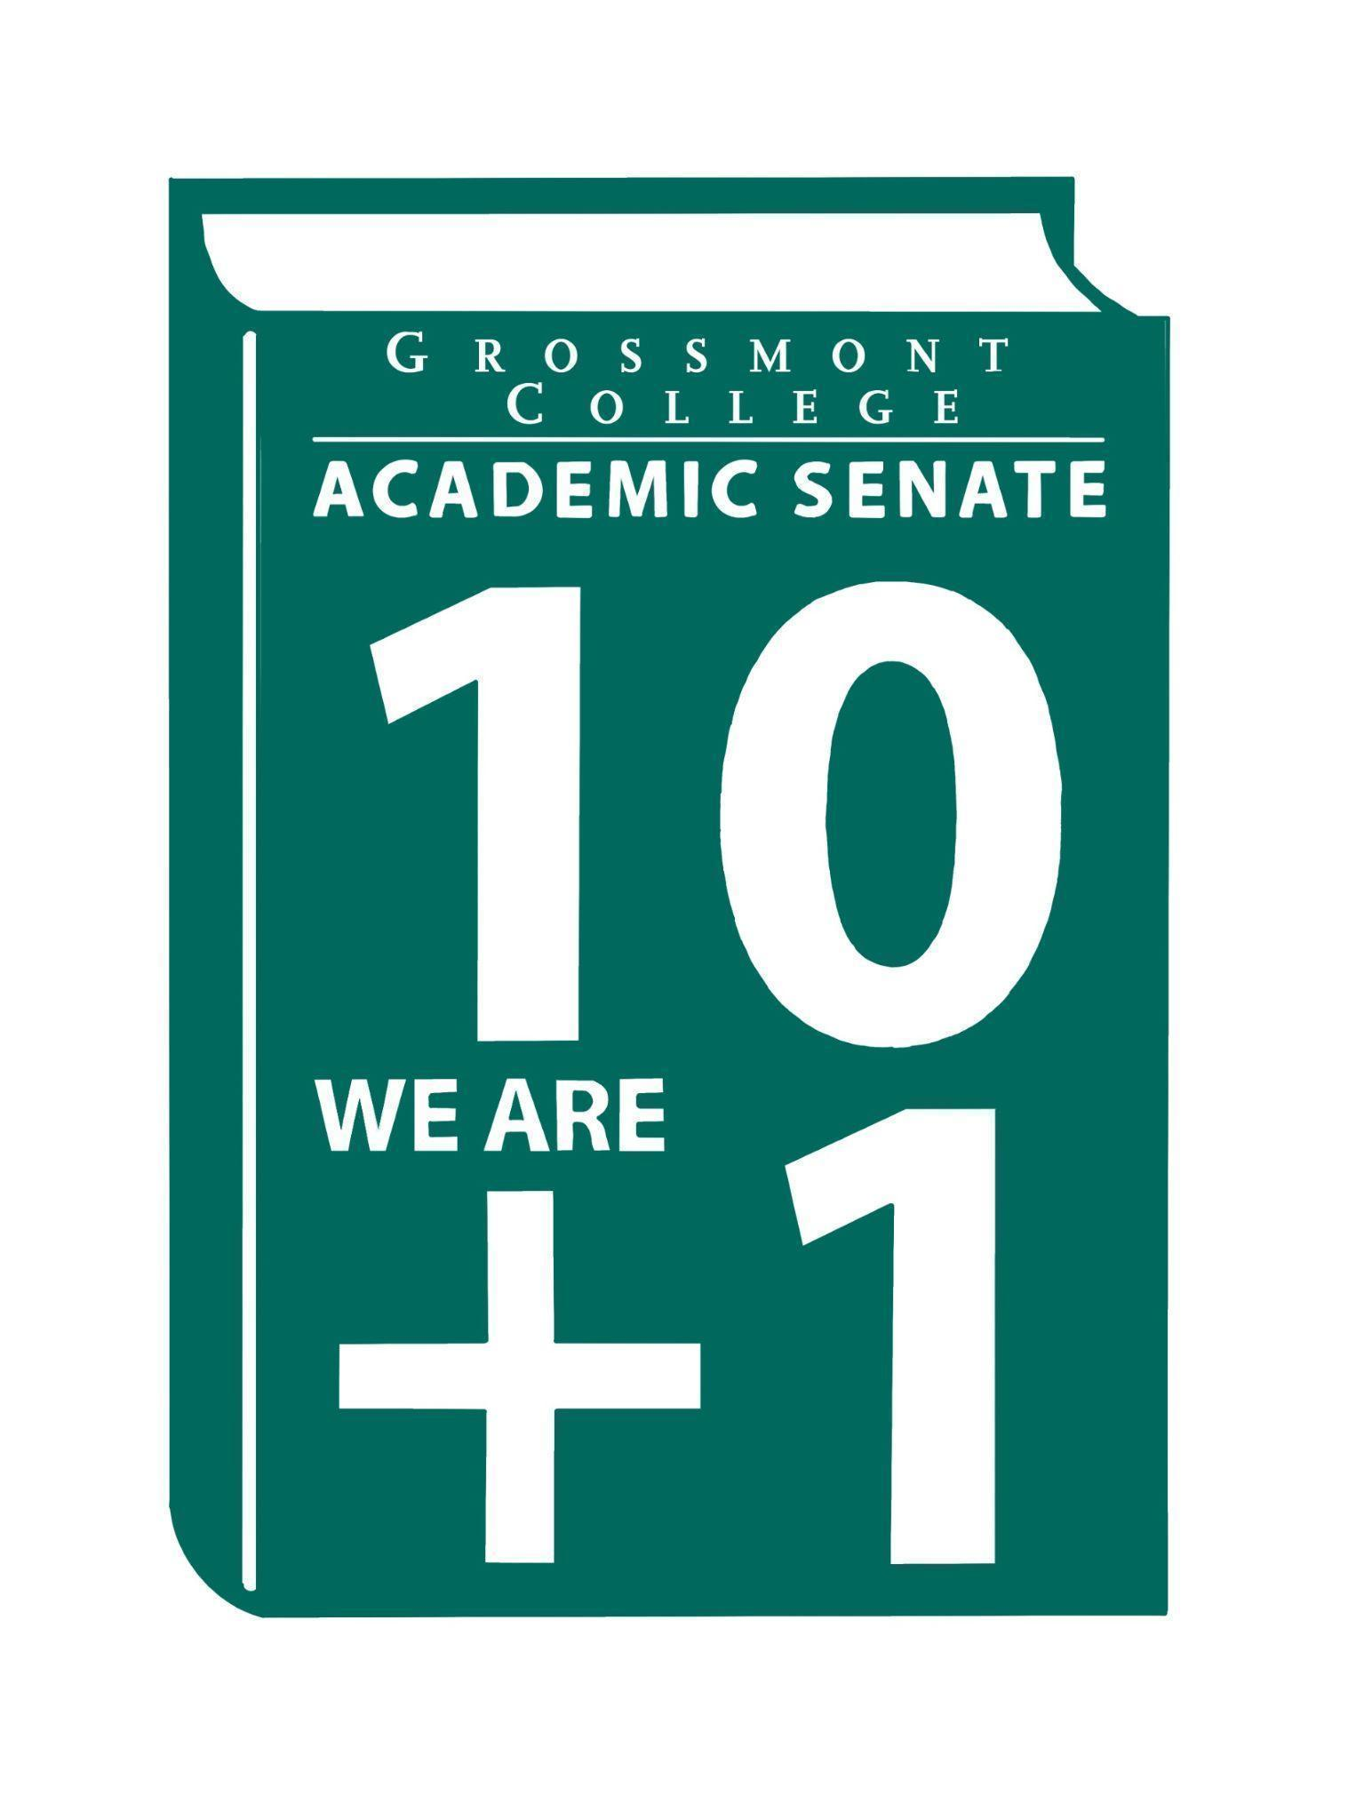

Meeting Minutes of the Academic Senate
Grossmont College
March 2, 2026
11:00 am-12:20 pm
ATTACHMENTS
1 | Call to Order 11:08 am
2 | Public Comment:  Lara Braff- Please review the Guided Pathways materials for accuracy and inform the lead if any updates are needed. Be sure to check the Guided Pathways website, especially the recent CCN changes, and verify that the Canvas shelves for each semester are correct.
3 | Approval of minutes from February 2, 2026.  VOTE: Minutes approved with no objections  Motion: J.Waller/J. Vanden Eynden
4 | Approval of Agenda  VOTE: Agenda approved with no objections  Motion: D. Aceves/J. VandenEynden
5  5.1  5.2  5.3  5.4 | Announcements  Ramadan Iftar Night on 3/4/26 (Griffin Gate)  Celebrate Ramadan with the Grossmont community.  Call-out for volunteers to serve on the Burden Free Access & Public Safety Taskforce  Correction regarding the Burden Free Access Taskforce: It was noted in the email thread that this is a subcommittee of OER; however, it will be a taskforce independent of the OER committee.  If you’re interested, a summary and link to sign up were included in the email thread.  Public Safety Taskforce collaboration with Cuyamaca college. Call out will be sent out for volunteers.  Preview of AS Canvas Container-Grossmont Academic Senate Canvas Shell  Dawn created Canvas Container for Academic Senate, please see if any changes are needed.  Spring 2026 Area D 3.13.26 2026 Spring Area D Meeting Registration  Registration for the meeting is available if you would like to attend in person or online on Friday, March 13. Area D refers to geographical location.
6  6.1  6.2  6.3  6.4  6.5  6.6  6.7 | President’s Report  CC Retreat (Enrollment Challenges/Strategies for improvement)  Chairs and Coordinators held their retreat. Highlevel overview is in attachments.  TOP to CIP (Mandate)  An email was sent from the district regarding the mandated timeline to update the TOP and CIP codes. Information will be posted. Comments were brought up regarding Cuyamaca’s push for online classes.  Draft of District MOU Approval & Implementation Process  Refresher: We previously signed an MOU with National University. A vote was taken to pause the MOU and not move forward at this time. There is a request for the district to have processes in place. Cuyamaca has reviewed the process. The document is included here at the district’s request for follow-up. Please provide feedback.  Reimaging Public Safety: The District is considering hiring a consultant to help identify college needs  We will establish our own taskforce. The district is considering hiring a consultant.  Accessibility (District Email)  The district sent an email to the campus regarding accessibility.  Academic Senate Action Item Voting Process  At the request of some colleagues, concerns were raised regarding the vote. Voting process will be discussed.  High-level overview of Board Document Reports: Citizens’ Bond Oversight Committee (CBOC) & Fiscal Year 2025-26 First Principal Apportionment-State Chancellor’s Memorandum Report  Presentations were given at the board meeting and are included in the attachments if you are interested.
7  7.1  7.2  7.3  7.4 | Information Items  Constitution & Bylaws (2nd Read)  The document is in the attachments folder. Please provide feedback so it can be moved forward as an action item.  Recommended Process to review the Senate's Constitution & Bylaws  It was recommended by a senator to create a process to review the Senate's Constitution & Bylaw.  BP 4035 Controversial Issues (Please Review)  It is important to review this document as it contains controversial issues taking place.  AP/BP 4230 Grading and Academic Symbols (Please Review)  This document discusses our policies and outlines procedures, including grading and reported symbols used for evaluation.
8  8.1  8.2  8.3 | Presentations  Overview of accessibility mandates (Interim President Luster, Interim VPSS Willis & Interim Sr. Dean Hurvitz)  Accessibility across campus was discussed, with a legal mandate coming in April. The institution is taking a campus-wide approach to ensure accessibility. A new position dedicated to accessibility was officially approved in March. Accessibility Hub made for all accessibility questions. The State Chancellor’s webinar is scheduled for Wednesday, March 4, from 11:00 AM to 12:00 PM. The session is titled: “Using Accessibility allowing AI to Move Courses toward Revised ADA Title II Regulations.” The focus should be prioritized on content that is currently in use, rather than on information from the past. Letter will be sent with general information.  A. Roe & D. Heuft: Advocacy for accessibility technology/tools. While Canvas website already includes some accessibility features, additional tools and best practices are being implemented:  - TidyUp can be used for accessibility checks.  - UDOIT can convert PDFs to Canvas pages.  *Shared Best practices guidelines for evaluating accessibility. The overarching goal is to promote consistency and focus on patterns not perfection. This is support for faculty’s growth by faculty. The document is located in 11.4 Canvas Resources.  *DE-Training Compensation Side letter approved. Effective immediately, faculty will be paid up to 20 hours of their non-classroom rate. This is retroactive to Fall 2025.  High-level overview of BDP Process (D. Aceves- Curriculum Chair)  Grossmont College conducts Feasibility Reviews of Instructional Programs to ensure alignment with the college’s mission and to confirm that student needs are being met. This process, governed by BP/AP 4020 and BP/AP 4021, involves examining programs and reviewing college catalogs to assess what each program entails. Outcomes of Feasibility Review include program initiation, modification, and discontinuance. Please refer to presentation slides in attachments for details.  Faculty Representatives Reports  - Senate Committees  - Participatory Governance Committees
9  9.1 | Action Items  Revised Resolution (ASGC)- Ensuring Precalculus Choice at Grossmont College after AB 1705  Motion to vote by acclimation: M. Molina/J. Yang  Motion Passes
10  10.1  10.2 | Vice-President’s Report/Unfinished Business-Tabled  Participatory Governance (open active recruitment)  Senators (Updated dept/division reps, specifically counseling)
11  11.1  11.2  11.3  11.4 | Future Agenda Items  Credit for Prior Learning (CPL)  Academic Ranking-Tenure Review Team  Review of Senator’s Roles/Communication  Human Resources Advisory Council (HRAC) AP/BPs
12 | ASCCC Webinars, Announcements, and Resources  - February 25, The Counselor’s Role in a Changing Landscape: Technology, Equity, and Vision 2030  - February 25, Transparency in Practice: The Brown Act and Recent Legislation  - March 4, The California Legislative Process & Faculty Advocacy  - March 6, 2026, ASCCC 2026 Spring Plenary Session, Scholarship Information/Deadline  - March 12, Nurturing the Seeds of Change: Supporting the Evaluation Process with IDEAA Tools  - The Academic Freedom Resource Guide is intended to support faculty with information to ensure they know their roles, rights, and responsibilities in the use of academic freedom; it includes links to a Playlab.ai bot trained to support research on academic freedom
13 | Adjournment:  VOTE: Motion to adjourn: A. Traylor/M. Molina  The meeting adjourned at 12:21.  Next meeting: March 16, 2026.

SIGN IN
3/2/2026 10:30:54 | Natalye Harpin | Senate Officer (Only SOC) | Interim VP/ Ethnic Studies
3/2/2026 10:55:28 | Michele Perchez | Senator | Biology
3/2/2026 10:56:27 | Denise Schulmeyer | Senator | Communication
3/2/2026 10:56:27 | Philip Bell | Senator | CSIS
3/2/2026 10:56:53 | Sebastien Cormier | Senator | Physics
3/2/2026 10:57:40 | Brian Keliher | Senator | Business
3/2/2026 10:58:25 | Daniel Gough | Senator | ALC
3/2/2026 10:58:42 | Hadeel Yaqoub | Senate Officer (Only SOC) | ESBS
3/2/2026 10:59:36 | Nemie Capacia | Senator | Math
3/2/2026 11:00:16 | Patrice Braswell | Senator | A.R.C.
3/2/2026 11:00:20 | Carey Flores | Senator | Respiratory therapy
3/2/2026 11:01:06 | Raymond Funk | Senator | Mathematics
3/2/2026 11:01:10 | Angela Feres | Senator | History
3/2/2026 11:01:21 | Randy Abshier | Senator | ESNH
3/2/2026 11:01:23 | Kathleen Banville | Senator | Theatre Arts
3/2/2026 11:01:26 | Ryan Gray | Senator | VAH
3/2/2026 11:02:16 | Nancy Saks | Guest | AHN
3/2/2026 11:02:43 | Gina Sorensen | Senator | Dance
3/2/2026 11:03:08 | Shawn Hicks | Guest | Math and Sciences Division
3/2/2026 11:03:14 | Jonathan Martin | Senator | History
3/2/2026 11:03:15 | Alan Traylor | Senate Officer (Only SOC) | English
3/2/2026 11:03:16 | Lara Braff | Senator | ANTH/Behavioral Sciences
3/2/2026 11:04:02 | Patricia a Ann Chow | Senator | CTE/Business
3/2/2026 11:04:04 | Jennifer Vanden Eynden | Senator | Mathematics
3/2/2026 11:04:17 | Adelle Roe | Guest | English/Online Ed
3/2/2026 11:04:23 | Scott Therkalsen | Senator | Earth Sciences
3/2/2026 11:05:10 | Holly Reed | Senator | OTA
3/2/2026 11:05:12 | Michael Perez | Senator | EOPS
3/2/2026 11:05:20 | June yang | Senate Officer (Only SOC) | Phil and Relg
3/2/2026 11:06:06 | Joel Castellaw | Senator | Communication
3/2/2026 11:06:18 | Felicia Kalker | Senator | Library
3/2/2026 11:06:40 | Regina Garcia | Senate Officer (Only SOC) | Cardiovascular Technology
3/2/2026 11:06:50 | Kelly menck | Senator | AOJ
3/2/2026 11:06:52 | Sarah Moore | Senator | Counseling/Transfer Center
3/2/2026 11:06:56 | Lynn Keane | Senator | BOT
3/2/2026 11:07:05 | Jeff Waller | Senator | Mathematics
3/2/2026 11:07:17 | Rebecca Handley | Senator | RESP
3/2/2026 11:07:25 | Diana Vance | Senator | Chemistry
3/2/2026 11:07:49 | Dawn Heuft | Guest | LTR
3/2/2026 11:07:53 | Michelle Crooks | Senator | English
3/2/2026 11:08:15 | Elisabeth Burke | Senator | Philosophy and Religious Studies
3/2/2026 11:08:46 | Diana Ramirez | Senate Officer (Only SOC) | Counseling
3/2/2026 11:08:54 | Wendy Cruzado | Guest | Counseling
3/2/2026 11:09:22 | Denise Aceves | Senator | Counseling
3/2/2026 11:09:28 | Jeanette Calo | Senator | MCOM
3/2/2026 11:10:15 | Victoria Curran | Senator | Communication
3/2/2026 11:10:36 | Brodney Fitzgerald | Senator | Physics and Astronomy
3/2/2026 11:10:52 | Ruth Navarro | Senator | WLD
3/2/2026 11:12:19 | Natalia Aylett | Senator | ESL
3/2/2026 11:13:30 | Robin Sepulveda | Senator | CDFS
3/2/2026 11:25:55 | Gareth Davies-Morris | Senator | Visual Arts and Humanities
3/2/2026 11:27:25 | James Holden | Senator | Bilogy
3/2/2026 11:35:09 | Judd Curran | Senator | Earth Sciences

