

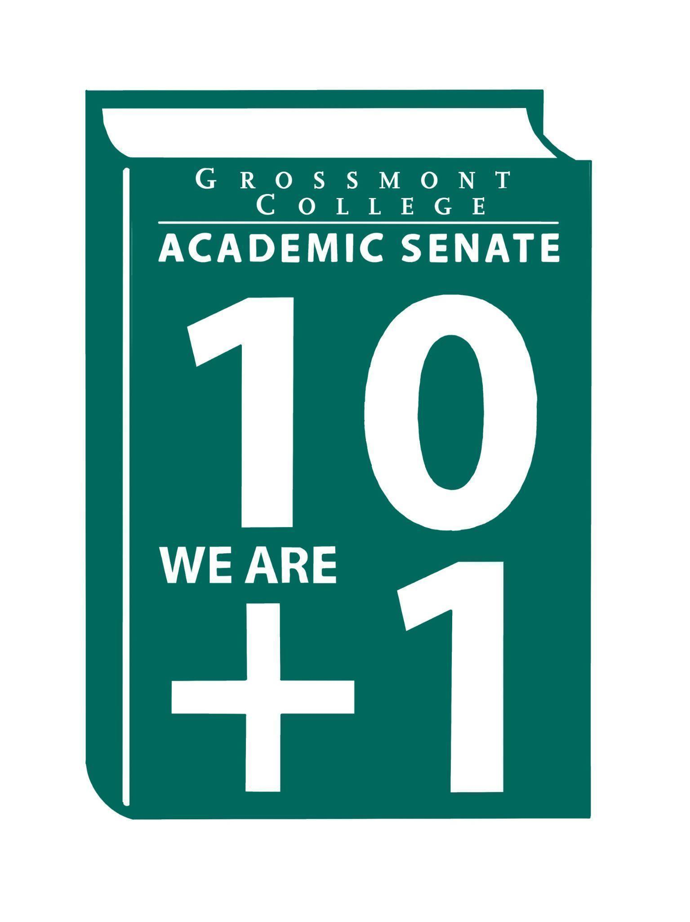

Meeting Minutes of the Academic Senate
Grossmont College
March 16, 2026
11:00 am-12:20 pm
ATTACHMENTS
1 | Call to Order 11:10 am
2 | Public Comment:  June Yang- AFT is circulating an amendment that, if it does not qualify and pass, would mean existing taxes would not be codified, which could jeopardize federal funding. The measure also aims to establish a tax on ultra-wealthy individuals. Dr. Yang asks for signatures for this petition.  Read a poem excerpt regarding social justice in our everyday lives from The Hill We Climb by Amanda Gorman.
3 | Approval of minutes from March 2, 2026.  VOTE: Minutes approved with no objections  Motion: J. Calo/D. Aceves
4 | Approval of Agenda  VOTE: Agenda approved with no objections  Motion: J. Waller/J. Calo
5  5.1  5.2  5.3  5.4  5.5 | Announcements  Call-out for volunteers to serve on the hiring committee for the Dean, English, Social & Behavioral Science (deadline to apply - 3-24-26)  Please submit your name to volunteer for the hiring committee. This Dean’s hiring committee is for the permanent position.  Spring Curriculum Regionals (College of the Desert - 4-4-26)  Attendance at the Curriculum Regionals is a great opportunity to connect with colleagues across the state while gaining up-to-date information on curriculum initiatives and resources. The registration link is accessible on the ASCCC website.  Food/Dining Options (Evening availability & Coffee Shop updates)  The president & VPAS are exploring evening food options for students. A free meal service called Every Day Table is being considered.  Spring 2026 Area D (2026 Spring Area D Meeting Registration 3.13.26)  Resolutions were reviewed. The link to the resolutions is in the attachments.  Chancellor & Classified Senate Award Nomination (nomination form due 4-10-26)  Please support our classified partners by submitting the award nomination (due April 10th).
6  6.1  6.2  6.3  6.4  6.5  6.6 | President’s Report  Follow-up-ACMM-Accessibility Maturity Model  High-level overview of the model.  - 1st: All new digital content created on or after April 24 must be accessible  Please check that your websites are accessible, and assistance is available.  - 2nd: Remediation of existing content  Documents such as PDFs should be updated to improve accessibility. Questions were raised about whether one-on-one videos for students must also meet accessibility standards. It was noted that videos are only required to be captioned if a student requests it or has specific captioning needs. There are also challenges in creating accurate captions for speakers with accents. A resource for captioning videos, called Otter.ai, was shared. Additionally, 3cmediasolutions.org is another captioning program. For general recordings, faculty are encouraged to use Studio, as it has a built-in accessibility feature.  ASCCC Disciplines List (deadline 9-30-26)  A high-level overview of the memorandum was conducted. ASCCC is now accepting proposals to revise the Disciplines List for the 2026–2027 cycle. The submission deadline is September 30, 2026. The information is available on the ASCCCs Discipline Lists webpage. Information on the current minimum qualifications can be found in the Minimum Qualifications for Faculty and Administrators in California Community Colleges.  Vision for leadership (Timeline to fill interim positions)  The leadership recruitment timeline completed by the College President was reviewed.  A new permanent dean position, the Dean of Exercise Science, Health, and Athletics, has been created and will be housed within athletics, aligning with Cuyamaca College. This will be housed under Student Services. The timeline is enclosed in the attachment folder.  Please submit names and volunteer interests.  Human Resources Advisory Council (HRAC): AP/BPs  There are several APs and BPs in the attachments, such as AP 3435. Please add comments to the side of the documents.  Faculty Protocol (Update-District)  An update was requested from the Chancellor regarding the faculty protocol, specifically outlining the process for advancing requests and the timeline from initial review to completion. During the discussion, the Chancellor noted that the document is comprehensive and that its implementation would have implications for other areas of participatory governance. She plans to review the document with the VCHR.  SWACC (Statewide Association of Community Colleges) Inspection Follow-up (District Memo)  Campus inspections identified several potential hazards, including obstructions to windows and doors. During the review of these findings, concerns were also raised about maintaining privacy during counseling appointments with students. Additionally, campus facilities vary by construction date; for example, newer Math buildings feature glass doors. This raises questions about whether window coverings, such as blinds, are permitted in these spaces. It was recommended that campus leadership seek clarification from SWACC on this issue during their next visit. Broad, one-size-fits-all recommendations from SWACC may have unintended impacts across multiple areas of the campus.
7  7.1  7.2  7.3  7.4  7.5 | Information Items  Draft of District MOU Approval & Implementation Process  The MOU process was completed by the Associate Vice Chancellor. Please provide input in the document's comments section so the feedback can be shared at the next ESSC meeting.  Recommended Process to review the Senate's Constitution & Bylaws  The recommended process for reviewing the Senate’s Constitutions and Bylaws was reviewed. Input/feedback is being requested before this document is moved forward for a vote.  Academic Senate Action Item Voting Process  The voting process for Action Items in the Senate was reviewed. Input/feedback is being requested before this document is moved forward for a vote.  BP 4035 Controversial Issues (Please Review)  Feedback is being requested for the next meeting.  AP/BP 4230 Grading and Academic Symbols (Please Review)
8  8.1  8.2  8.3 | Presentations  OER/ZTC-Verification Process (Zayden Tethong)  Discussions were held regarding the definition of ZTC (Zero Textbook Cost). A new ZTC form, updated annually, has been created. Using this data, a new process was developed. The master spreadsheet will be shared with Chairs and Deans. During the linesheet review, faculty will be responsible for verifying ZTC information, section by section.  FPSC Charge & Composition (Brodney Fitzgerald)  The Faculty Staffing Prioritization Committee (FPSC) outlines its purpose, responsibilities, and five key objectives. Proposed FPSC membership includes representatives from each campus division.  Faculty Representatives Reports  - Senate Committees  - Participatory Governance Committees-  - Facilities/Budget/PIEC/FPSC
9  9.1 | Action Items  GC Constitution & Bylaws (Revised)  Moved to the next meeting.
10  10.1  10.2 | Vice-President’s Report/Unfinished Business-Tabled  Participatory Governance (open active recruitment)  Senators (Updated dept/division reps, specifically counseling)
11  11.1  11.2  11.3  11.4 | Future Agenda Items  Academic Ranking-Tenure Review Team (Nadra Farina-Hess)  CPL Update  Review of Senator’s Roles/Communication  College President’s Forum-tentative
12 | ASCCC Webinars, Announcements, and Resources  - Equivalency Without Chaos: Effective Practices for Local Academic Senates in Multi-College Districts  Monday, March 23, 2-3:00 pm  - Follow-Up Office Hours: Effective Equivalency Practices for Local Academic Senates in Multi-College Districts  Monday, March 23, 3-4:00 pm  - Authentic Assessments and Academic Integrity in the Age of AI  Wednesday, March 25, 12-1:00 pm  - Common Course Numbering (CCN) Office Hours  Wednesday, April 1, 2-3:00 pm  Monday, April 27, 1-2:00 pm  - The Academic Freedom Resource Guide is intended to support faculty with information to ensure they know their roles, rights, and responsibilities in the use of academic freedom; it includes links to a Playlab.ai bot trained to support research on academic freedom
13 | Adjournment:  VOTE: Motion to adjourn: J. Calo/J. Waller/J. Vanden Eynden  The meeting adjourned at 12:20.  Next meeting: April 6, 2026.

Committee Representative Communication & Feedback Form (Responses) 3/16/26
Classified Staffing Prioritization Committee
College Council
Technology Committee
Professional Advancement Committee
Facilities Committee

SIGN IN
3/16/2026 10:44:20 | Philip Bell | Senator | CSIS
3/16/2026 10:54:01 | June Yang | Senate Officer (Only SOC) | Phil & Relg
3/16/2026 10:54:20 | Angela Feres | Senator | History
3/16/2026 10:57:03 | Kathleen Banville | Senator | Theatre Arts
3/16/2026 10:57:54 | Jonathan Martin | Senator | History
3/16/2026 10:58:05 | Denise Schulmeyer | Senator | Communication
3/16/2026 10:58:11 | Regina Garcia | Senate Officer (Only SOC) | CVT
3/16/2026 10:58:30 | James Holden | Senator | Biology
3/16/2026 10:59:16 | Natalye Harpin | Senate Officer (Only SOC) | Ethnic Studies
3/16/2026 10:59:56 | Brian Keliher | Senator | Bus Adm
3/16/2026 11:00:48 | Randy Abshier | Senator | ESNH
3/16/2026 11:00:57 | Alan Traylor | Senate Officer (Only SOC) | English
3/16/2026 11:01:02 | Nemie Capacia | Senator | Math
3/16/2026 11:01:17 | Sarah Moore | Senator | Transfer Center
3/16/2026 11:01:44 | Ryan Gray | Senator | VAH
3/16/2026 11:01:48 | Felicia Kalker | Senator | Library
3/16/2026 11:02:05 | Carey Flores | Senator | Respiratory therapy
3/16/2026 11:02:22 | Daniel Gough | Senator | ALC
3/16/2026 11:02:55 | Martin Larter | Senator | Chemistry
3/16/2026 11:03:09 | Victoria Curran | Senator | Communication
3/16/2026 11:03:58 | Gina Sorensen | Senator | Dance
3/16/2026 11:04:45 | Raymond Funk | Senator | Mathematics
3/16/2026 11:04:55 | Michael Perez | Senator | EOPS
3/16/2026 11:05:41 | Lynn Keane | Senator | BOT
3/16/2026 11:05:47 | Karen Caires | Senator | Exercise Science, Nutrition and Health
3/16/2026 11:05:51 | Lara Braff | Senator | ANTH/Behavioral Sciences
3/16/2026 11:06:00 | Michael Bacon | Senator | Psychology
3/16/2026 11:06:07 | Brodney Fitzgerald | Senator | Physics and Astronomy
3/16/2026 11:06:11 | Jennifer Vanden Eynden | Senator | Math
3/16/2026 11:06:15 | Scott Therkalsen | Senator | Earth sciences
3/16/2026 11:06:28 | Amanda Clay | Senator | Orthopedic Tech Program
3/16/2026 11:06:29 | Malia Molina | Senator | Art History / ALC
3/16/2026 11:06:36 | Michelle Crooks | Senator | English
3/16/2026 11:06:55 | Jeanette Calo | Senator | MCOM
3/16/2026 11:07:02 | Joel Castellaw | Senator | Communication
3/16/2026 11:07:27 | Diana Vance | Senator | Chemistry
3/16/2026 11:07:44 | Robin Sepulveda | Senator | CDEFS
3/16/2026 11:09:19 | Judd Curran | Senator | Earth Sciences
3/16/2026 11:09:42 | Jeff Waller | Senator | Mathematics
3/16/2026 11:10:01 | Ruth Navarro | Senator | World Languages
3/16/2026 11:10:32 | Zayden Tethong | Guest | Library
3/16/2026 11:10:57 | Debbie Rose | Senator | RT
3/16/2026 11:11:03 | Rebecca Handley | Senator | RESP
3/16/2026 11:12:59 | Denise Aceves | Senator | coun
3/16/2026 11:33:30 | Gareth Davies-Morris | Senator | Visual Arts and Humanities
3/16/2026 12:21:13 | Diana Ramirez | Senate Officer (Only SOC) | Counseling

