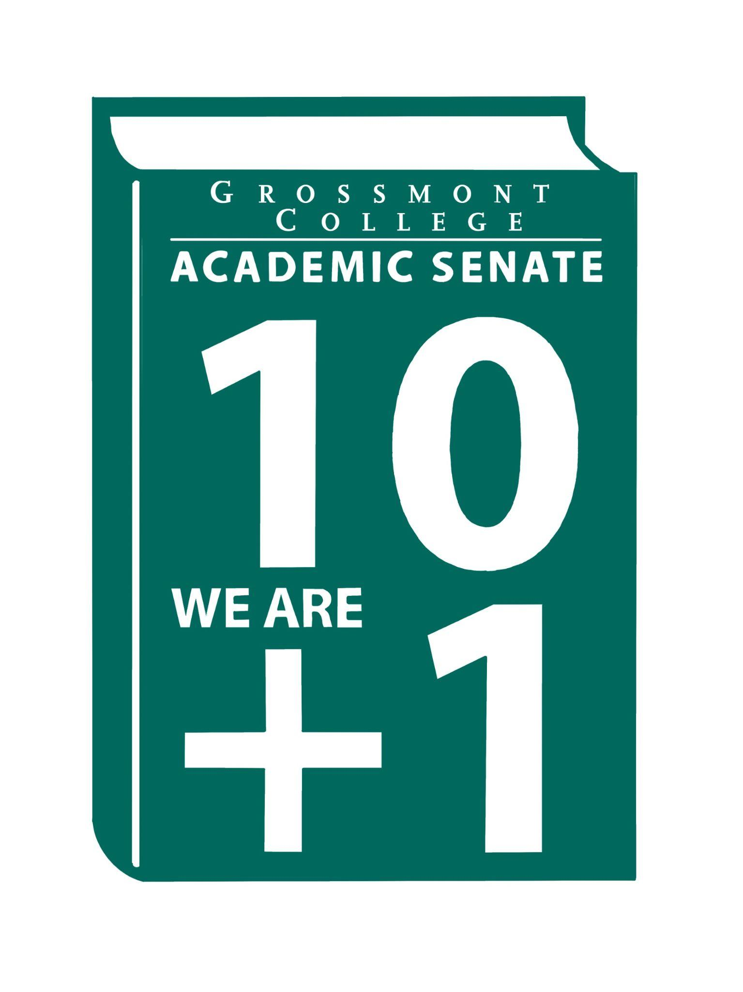  10 + 1  Title 5 §53200(b): Academic Senate means an organization whose primary function is to make recommendations with respect to academic and professional matters. In Sections 53200(c),  "Academic and professional matters" means the following policy development and implementation matters:  (1) curriculum, including establishing prerequisites and placing courses within disciplines;  (2) degree and certificate requirements;  (3) grading policies;  (4) educational program development;  (5) standards or policies regarding student preparation and success;  (6) district and college governance structures, as related to faculty roles;  (7) faculty roles and involvement in accreditation processes, including self-study and annual reports;  (8) policies for faculty professional development activities;  (9) processes for program review;  (10) processes for institutional planning and budget development; and  (11) other academic and professional matters as are mutually agreed upon between the governing board and the academic senate  District/College is to “rely primarily upon the advice and judgment”  (5 CCR 53200(d)) Of the A.S. in the following areas:  COLLEGE MISSION STATEMENT  MISSION  Grossmont College serves the diverse population of our surrounding community and beyond by creating clear and accessible pathways to degrees and careers that lead to social and economic mobility for our students. We work collaboratively to cultivate an equitable student-centered learning environment, and we hold ourselves accountable for improving student outcomes through ongoing assessment, evaluation, and data-informed decision-making. Grossmont.  PROCESSES FOR  COLLEGIAL CONSULTATION  (5 CCR 53200(d) & GCCCD AP 2510)  *The Board will Rely Primarily Upon  the Academic Senate  **The Board will seek Mutual  Agreement with the Academic Senate. |   Academic Senate Agenda  Monday, April 20, 2026  11:00 am–12:20 pm  Griffin Gate  ATTACHMENTS  - Call to Order - 11:00 AM  - Public Comment—Persons wishing to address the Senate will be given a maximum of 4 minutes to address the Senate about a non-agendized item or items, with a maximum of 15 minutes allowed for public comment. The Senate may vote to extend public comment at any meeting. If you wish to speak during public comment, please complete the attached form by Thursday, within 72 hours of the scheduled academic senate meeting. The Senate will still welcome public comment on the scheduled meeting day, and it may continue at the end of the meeting if necessary.  - Approval of minutes (4/6/2026) (2 min)  - Approval of Agenda (2 min)  - Announcements  5.1 Reminder-request for volunteers to serve on the Participatory Governance Committees (Deadline to apply 4-23-26)  5.2 Black Student Success Week (April 20-24; 12-1 pm-The Village )  5.3 Distinguished Faculty Nominations (Deadline to submit 4-24-26)  5.4 Student of Note Nominations (Deadline to submit 4-24-26)  5.5 Last Day for students to Drop Full-term Classes (with "W" 5-2-26)  6. President’s Report (10 min)  6.1 Spring Plenary Resolutions (Final Resolutions are available ASCCC website)  6.2 College President is planning a forum (Please register to attend)  6.3 Participatory Governance Guidelines (Roles and Responsibilities)  6.4 Academic Ranking (Voting facilitated electronically)  7. Information Items: Updates and information are presented for discussion and feedback, including the introduction of items that will need constituency feedback and a vote of approval or endorsement at the next meeting.  7.1 Resolution in Support of Pan African Virtual College  7.2 BP 4035-Controversial Issues  7.3 BP 4010 Academic Calendar  8. Presentations  8.1 OTLC Committee-RSI Recommendations (15 mins)  8.2 Credit for Prior Learning (CPL) Evan Wirig  8.3 Faculty Representatives Reports  - Senate Committees  - Participatory Governance Committees-  - Facilities/Budget/PIEC/FPSC  - EEOAC (Update-District)  - TPPG (Update-District)  9. Action Items  9.1 GC Constitution & Bylaws (Revised)  9.2 Recommended Process to review the Senate's Constitution & Bylaws  10. Vice-President’s Report/Unfinished Business  10.1 Participatory Governance (open active recruitments)  10.2 Senators (Updating dept/division reps, specifically counseling)  11. Future Agenda Items  11.1 AI Taskforce  11.2 College Recognition Ceremony  11.3 Academic Senate Action Item Voting Process  12. ASCCC Webinars, Announcements, and Resources  April 18, 10:00am-3:00pm  - Come join us in person or via Zoom to network, share, and discuss with other Rising Scholars faculty. We hope to gather Rising Scholars faculty coordinators, counselors, and instructors both inside and outside system facilities. There will be opportunities for coordinators and counselors to share and discuss issues pertaining to coordinating programs and Rising Scholars, as well as opportunities for instructional faculty teaching Rising Scholars inside and outside facilities to discuss pedagogy with other Rising Scholars faculty. The ASCCC Rising Scholars Faculty Advisory Committee will also be taking input from these consortia on what future resources to work on and topics for future webinars and convenings, developed by Rising Scholars faculty for Rising Scholars faculty.  April 24, 1-2:00 pm  - Join the ASCCC Part-Time Faculty Committee for a special one-hour Zoom webinar celebrating the outstanding work part-time faculty are doing across California's community colleges. This event provides an opportunity for part-time faculty to share their unique contributions to student success and today's dynamic learning experiences. Come be part of this engaging session as we shine a spotlight on the dedication, innovation, and impact that part-time faculty bring to their classrooms every day.  Monday, April 27, 1-2:00 pm  - The Academic Freedom Resource Guide is intended to support faculty with information to ensure they know their roles, rights, and responsibilities in the use of academic freedom; it includes links to a Playlab.ai bot trained to support research on academic freedom  April 29, 11:00 am-12:00 pm  - Do you have questions and/or curiosity about AI and teaching strategies, class policies, student or instructor use of AI tools, or any other topic around AI and pedagogy? Join these office hours to ask your questions, bounce your ideas off attendees, or even just listen to what other faculty have to share/ask. Feel free to enjoy your snack/beverage/lunch with us while you attend.  April 30-May 1  - The Noncredit Movement: Have you registered for the Noncredit Institute? The last day to register is April 20.  May 5, 1-2:00 pm  - Volunteering for statewide service is one of the most impactful ways faculty can contribute to the work of the Academic Senate for California Community Colleges. This session provides a clear overview of what statewide service looks like, including the types of committees and services available, who can participate, how the appointment process works, and the typical time commitment involved. We’ll discuss how faculty can identify committees that align with their interests, strengths, and leadership goals, and how statewide service can deepen your understanding of systemwide issues while strengthening your voice in academic and professional matters. Join us to learn how to get involved and what to expect when serving at the state level.  13. Adjournment – Next meeting 5/4/26

