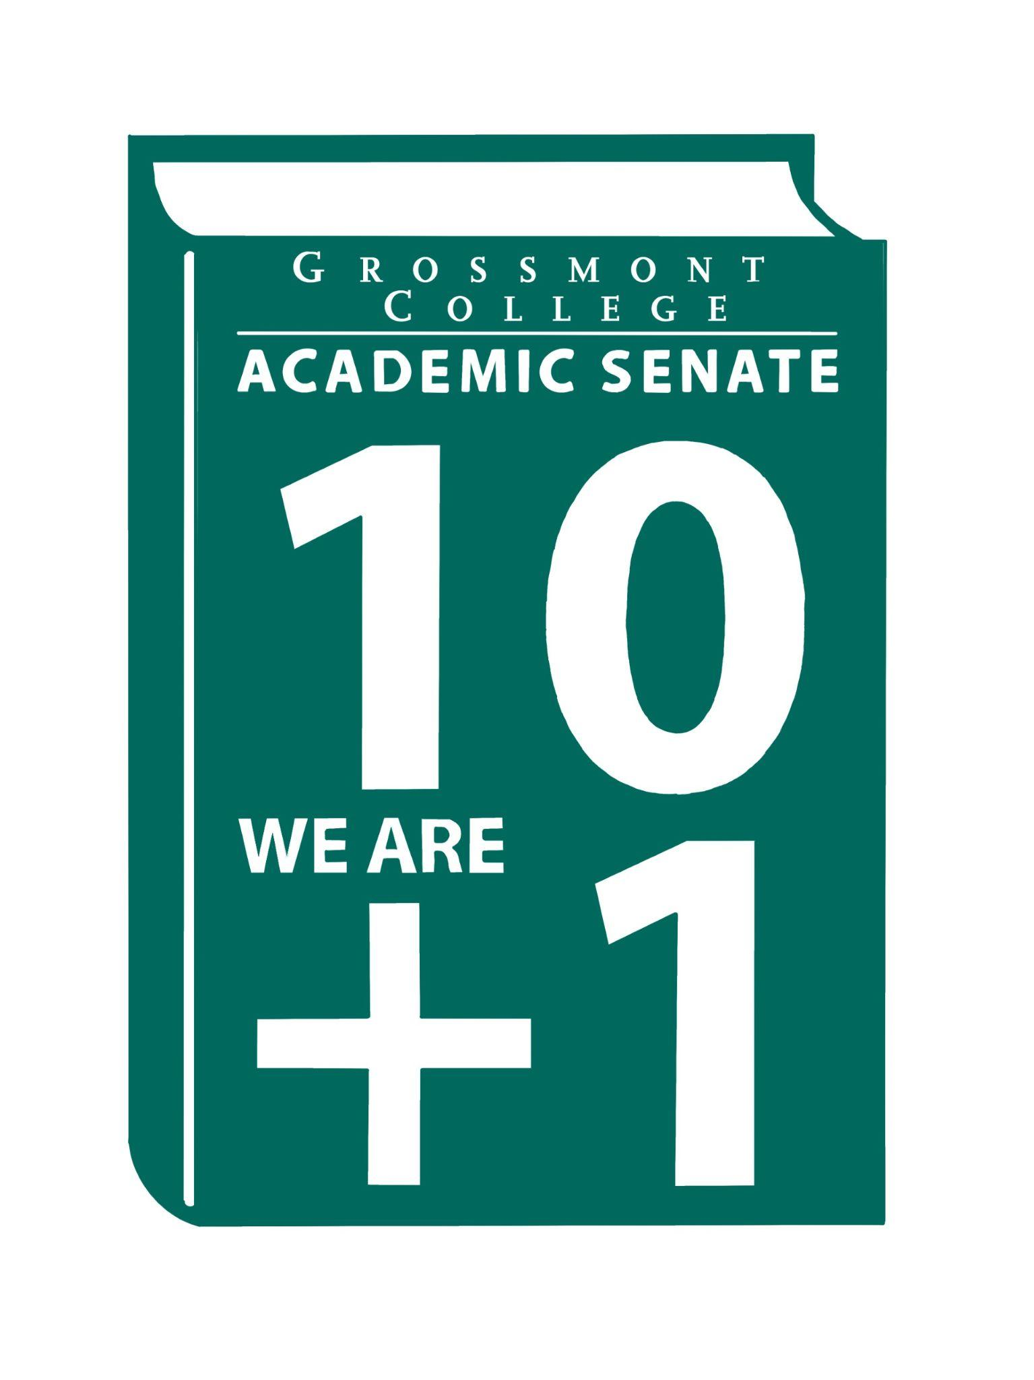  10 + 1  Title 5 §53200(b): Academic Senate means an organization whose primary function is to make recommendations with respect to academic and professional matters. In Sections 53200(c),  "Academic and professional matters" means the following policy development and implementation matters:  (1) curriculum, including establishing prerequisites and placing courses within disciplines;  (2) degree and certificate requirements;  (3) grading policies;  (4) educational program development;  (5) standards or policies regarding student preparation and success;  (6) district and college governance structures, as related to faculty roles;  (7) faculty roles and involvement in accreditation processes, including self-study and annual reports;  (8) policies for faculty professional development activities;  (9) processes for program review;  (10) processes for institutional planning and budget development; and  (11) other academic and professional matters as are mutually agreed upon between the governing board and the academic senate  District/College is to “rely primarily upon the advice and judgment”  (5 CCR 53200(d)) Of the A.S. in the following areas:  COLLEGE MISSION STATEMENT  MISSION  Grossmont College serves the diverse population of our surrounding community and beyond by creating clear and accessible pathways to degrees and careers that lead to social and economic mobility for our students. We work collaboratively to cultivate an equitable student-centered learning environment, and we hold ourselves accountable for improving student outcomes through ongoing assessment, evaluation, and data-informed decision-making. Grossmont.  PROCESSES FOR  COLLEGIAL CONSULTATION  (5 CCR 53200(d) & GCCCD AP 2510)  *The Board will Rely Primarily Upon  the Academic Senate  **The Board will seek Mutual  Agreement with the Academic Senate. |   Academic Senate Agenda  Monday, March 16, 2026  11:00 am–12:20 pm  Griffin Gate  ATTACHMENTS  - Call to Order - 11:00 AM  - Public Comment—Persons wishing to address the Senate will be given a maximum of 4 minutes to address the Senate about a non-agendized item or items, with a maximum of 15 minutes allowed for public comment. The Senate may vote to extend public comment at any meeting. If you wish to speak during public comment, please complete the attached form by Thursday, within 72 hours of the scheduled academic senate meeting. The Senate will still welcome public comment on the scheduled meeting day, and it may continue at the end of the meeting if necessary.  - Approval of minutes (3/2/2026) (2 min)  - Approval of Agenda (2 min)  - Announcements  5.1 Call-out for volunteers to serve on the hiring committee for the Dean, English, Social & Behavioral Science (deadline to apply - 3-24-26)  5.2 Spring Curriculum Regionals (College of the Desert - 4-4-26)  5.3 Food/Dining Options (Evening availability & Coffee Shop updates)  5.4 Spring 2026 Area D (2026 Spring Area D Meeting Registration 3.13.26)  5.5 Chancellor & Classified Senate Award Nomination (nomination form due 4-10-26)  - President’s Report (10 min)  6.1 Follow-up-ACMM-Accessibility Maturity Model  - 1st: All new digital content created on or after April 24 must be accessible.  b. 2nd: Remediation of existing content  6.2 ASCCC Disciplines List (deadline 9-30-26)  6.3 Vision for leadership (Timeline to fill interim positions)  6.4 Human Resources Advisory Council (HRAC): AP/BPs  6.5 Faculty Protocol (Update-District)  6.6 SWACC (Statewide Association of Community Colleges) Inspection Follow-up (District Memo)  7. Information Items: Updates and information are presented for discussion and feedback, including the introduction of items that will need constituency feedback and a vote of approval or endorsement at the next meeting.  7.1 Draft of District MOU Approval & Implementation Process  7.2 Recommended Process to review the Senate's Constitution & Bylaws  7.3 Academic Senate Action Item Voting Process  7.4 BP 4035 Controversial Issues (Please Review)  7.5 AP/BP 4230 Grading and Academic Symbols (Please Review)  8. Presentations  8.1 OER/ZTC-Verification Process (Zayden Tethong)  8.2 FPSC-Brodney Fitzgerald  8.3 Faculty Representatives Reports  - Senate Committees  - Participatory Governance Committees-  - Facilities/Budget/PIEC/FPSC  9. Action Items  9.1 GC Constitution & Bylaws (Revised)  10. Vice-President’s Report/Unfinished Business  10.1 Participatory Governance (open active recruitments)  10.2 Senators (Updating dept/division reps, specifically counseling)  11. Future Agenda Items  11.1 Academic Ranking-Tenure Review Team (Nadra Farina-Hess)  11.2 CPL Update  11.3 Review of Senator’s Roles/Communication  11.4 College President’s Forum-tentative  12. ASCCC Webinars, Announcements, and Resources  - Equivalency Without Chaos: Effective Practices for Local Academic Senates in Multi-College Districts  Monday, March 23, 2-3:00 pm  - Follow-Up Office Hours: Effective Equivalency Practices for Local Academic Senates in Multi-College Districts  Monday, March 23, 3-4:00 pm  - Authentic Assessments and Academic Integrity in the Age of AI  Wednesday, March 25, 12-1:00 pm  - Common Course Numbering (CCN) Office Hours  Wednesday, April 1, 2-3:00 pm  Monday, April 27, 1-2:00 pm  - The Academic Freedom Resource Guide is intended to support faculty with information to ensure they know their roles, rights, and responsibilities in the use of academic freedom; it includes links to a Playlab.ai bot trained to support research on academic freedom  13. Adjournment – Next meeting 4/6/26

