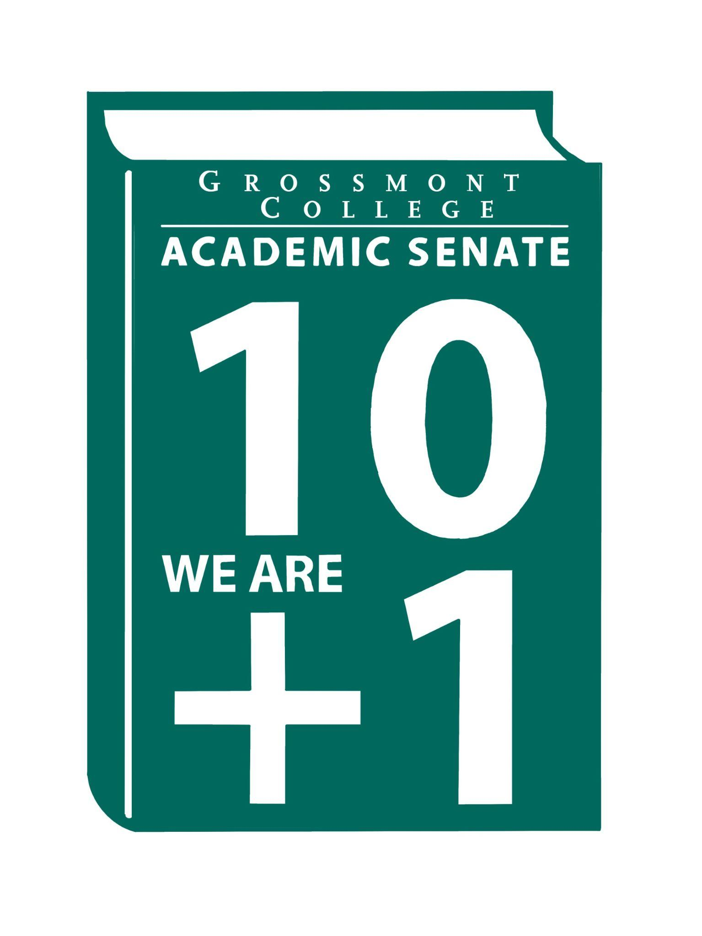
To Dee Aceves, chair of the Academic Senate committees, thank you for running a tight, highly efficient ship with the curriculum submission and review process. Your leadership has streamlined dated processes, maintained rigorous timelines to meet CCN deadlines, kept the college informed and responsive to evolving Title 5 curriculum changes, and navigated what often feels like the encyclopedia-sized volume of curriculum modifications and submissions. Taking on the recent TOP-to-CIP mandate transition was no small feat, yet you and the Curriculum Committee handled it with professionalism and precision. Curriculum Committee members, you are truly exceptional, and your work is foundational to Grossmont College's academic integrity and excellence.
To Adelle Roe and Angela Feres, chairpersons of Online Teaching and Learning: thank you for your steadfast advocacy and leadership in advancing quality online education. Grossmont College understands the critical importance of Regular and Substantive Interaction (RSI) and accessibility in supporting equitable student success. Yes, a few of us have played the deck of cards in POCR, but through it all, our Distance Education/OTLC team has continued to lead with innovation, patience, and purpose. OTLC team, you rock!
To Elisabeth Burke, chair of Faculty Professional Development, we already know Flex Week is likely on your mind before the current semester even ends. Thank you for helping guide the college through each semester with professional development opportunities, workshop call-outs, and countless hours dedicated to faculty growth and engagement. To the entire FPD Committee team, thank you for your energy, creativity, and commitment to lifelong learning. Keep being awesome!
To Joyce Fries & Kelly Menck: thank you for your tremendous hard work, dedication, and thoughtful leadership throughout this year’s Program Review process. The time, care, and professional expertise you invested in reviewing programs and completing reports have been invaluable to the college community. The Program Review process is essential to maintaining the integrity and excellence of our academic programs, and your leadership helped foster a collaborative and supportive environment that encourages innovation, equity-minded practices, and data-informed decision-making.
To Zayden Tethong and the OER/ZTC team, thank you for your continued advocacy on behalf of our students. Your work in providing faculty with resources, guidance, and support on Open Educational Resources and Zero-Textbook-Cost pathways has significantly reduced barriers to education and expanded equitable access for countless students. The impact of your work reaches far beyond the classroom.
To Nadra Farina Hess, the chair of the Professional Advancement Committee, thank you for the careful review and stewardship of faculty advancement applications and distinguished faculty recognitions. Your work helps honor excellence, scholarship, and dedication across our campus community. And regarding the sabbatical review process. Just a thought!
To Richard Unis, our Part-Time Faculty chair, thank you for your ongoing support of our adjunct colleagues. Your advocacy and representation matter deeply, and your work continues to strengthen equity and inclusion and to support part-time faculty across the college.
Finally, I want to extend my gratitude to all faculty representatives serving on participatory governance committees throughout the institution. As an islander would say, "big ups" to you all. Your willingness to serve, contribute, advocate, and represent faculty voices across campus spaces embodies the very spirit of collegial consultation and shared governance that makes Grossmont College stronger. Your efforts ensured that processes remained grounded in meaningful reflection, continuous improvement, and institutional accountability, all while aligning with the mission, vision, and strategic goals of Grossmont College. Through your commitment, departments were able to engage in important dialogue about program effectiveness, student success, resource needs, and long-range planning.
To the GC Collective, we remain one band, one sound. We are stronger together.

With Appreciation,
Sharon
Diana
Adam
Natalye
Richard
June
Hadeel

